Type of Contribution: PAPER

The gap between users and cataloguers: perception of importance of bibliographic data for required reading and leisure reading

Mihela Pauman Budanović, Faculty of Arts, University of Ljubljana, Slovenia, mihela.pauman@ff.uni-lj.si
Katarina Švab, Faculty of Arts, University of Ljubljana, Slovenia, katarina.svab@ff.uni-lj.si
Maja Žumer, Faculty of Arts, University of Ljubljana, Slovenia, maja.zumer@ff.uni-lj.si
Keywords: users, cataloguers, library catalogue, bibliographic data, information need

Introduction

The objectives of facilitating end user retrieval and maintaining the catalogue integrity represent two different perspectives, but both must be taken into account. Especially since diversity, inclusiveness, and flexibility are becoming increasingly important principles of information organization, as the consequence of higher expectations.
It is important to fill the gap between end users and cataloguers, who are largely responsible for what is included in bibliographic records. Most cataloguers never face their users directly, on the other hand, the users’ feedback cannot reach cataloguing process easily (Xiaojuan and Na 2012).
Therefore, we decided to investigate which information, in cataloguers’ opinion, can best serve different users’ needs and which elements users actually want to see in a library catalogue.
This paper provides some insight into cataloguers’ as well as end users’ perception about the importance of bibliographic data of fiction for two purposes: required reading for school and leisure reading.

Theoretical framework
Librarians as well as end users approach catalogues purposefully. End users generally want to find and obtain a resource. On the other hand, librarians are more experienced users. They search on behalf of their users and in the context of other duties. In order to present the full picture, it is necessary to bridge the gap between end users’ expectations and library professionals’ perceptions about what constitutes a quality bibliographic description. In 2009, OCLC conducted a study Online Catalogs: What Users and Librarians Want, which describes a disconnection between the librarian’s perception of catalogue quality and the user’s, caused by different viewpoints and objectives (Calhoun et al. 2009). End users’ expectations of data quality are heavily influenced by search engines. Therefore they expect the library catalogue to function as a web search engine (Novotny 2004, 533). But unlike search engines, which retrieve data directly from full-text documents, search terms in online catalogues are provided by cataloguers in form of structured bibliographic data (Mi and Weng 2008, 8).
On the other hand, librarians’ views of the data quality are often influenced by their work roles and experience, specific demands of their position and traditional principles of information organization, which can have a great impact especially on cataloguing. They are focused on efficient and correct data entry, the elimination of duplicate records and fixing MARC coding errors (Snow 2017; Calhoun et al. 2009, 49). Simply considering that quality cataloguing should be accurate and complete, or should follow specific standards, is not enough, though.
Several researchers have reported that bibliographic records are not as useful, as expected by users (Petrucciani 2015; Hider and Tan 2008). There is a lack of additional data (such as summary, cover image etc.) that could improve the functionality of the catalogue (Hypén, 2014, Hider, 2008). The most problematic are especially bibliographic records for fiction. Considering studies (Mikkonen and Vakkari 2012; Goodall 1989), the usage of library catalogue to access fiction is very low (between 10-20 percent).
The extent to which users use bibliographic data in a catalogue is largely dependent on what bibliographic data is there. Users use whatever they are given. Moreover, they use the principle of least effort in their information seeking. Cataloguers should think about the impact and the benefit of cataloguing to library users and create enriched bibliographic records in order to establish the best connection between users and library materials, based on users’ expectations (Diao and Hernandez 2014). In the literature we can trace a number of recommendations on how to provide more value-added information (Hypén 2014), but not enough concerning the relationship between users and cataloguing (Xiaojuan and Na 2012).

Research questions
Our main research questions were:
- Which attributes cataloguers find the most important to help different types of users with different needs (for example leisure reading, required reading for school…) find, identify, select and obtain the publication?
- Which bibliographic data are the most important for high school students when they identify and select books for assigned reading and which attributes are the most important for adults to identify and select fiction for leisure reading using the catalogue?

Methodology
Multiple data collection methods were used: observation, think aloud protocol and in-depth interviews to obtain information about opinions of users and cataloguers about the importance of bibliographic elements.
We conducted two studies with users in school libraries and in public libraries in 2011 and 2012. There were two groups of users: 105 high school students and 108 users of public libraries. For the first study with high school students, we created enriched bibliographic records for different versions of Don Quixote by Miguel de Cervantes Saavedra. For the second study with adult readers, we used three different types of bibliographic records for versions of The Godfather by Mario Puzo. One type of bibliographic record was taken from current Slovenian library catalogue COBISS, the other two types were created as enriched bibliographic records.
We were able to compare the results with those obtained in the study with cataloguers.
In the description of monographic publications study we used a think-aloud protocol to determine how cataloguers would describe publications in such a way to best support different types of users with different types of information needs in their tasks of finding, identifying, selecting and obtaining the appropriate publication, without the restrictions of a particular cataloguing module.
The first study was conducted in June 2014 among 30 Slovenian cataloguers from seven libraries. Romeo and Juliet by William Shakespeare was selected to serve as a representative case for required reading. The second study was conducted in February and March 2016 among 32 participants from six different libraries. We used the same title for leisure reading case (The Godfather)
The nature of publications selected was quiet similar in both studies, with a variety of distinctive elements, such as different translations, an illustrated edition, different series, publication with the foreword, editions in two or four volumes, abridged editions etc.
Due to a relatively small sample size of cataloguers we were interested to retrieve qualitative and not quantitative data from both studies.

Research Results
The purpose of the analysis carried out for this paper was to investigate what kinds of information, in cataloguers’ opinion, might be beneficial for users in different information seeking situations in comparison with end users’ expectations.
Table 1 shows which data elements cataloguers as well as end users found the most important for fiction. Author and title, as the most obvious information, was not taken into account. We took into account only attributes that were identified by at least three participants. On average, cataloguers mentioned seven (Romeo and Juliet) or eight (The Godfather) descriptive elements, while adults and high school students pointed out only three.

Table 1. Important attributes 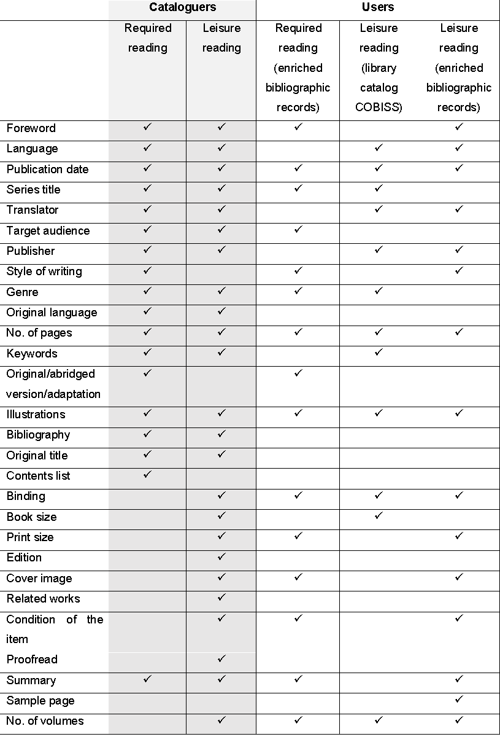
We were able to identify and compare which attributes catalogue end users and cataloguers found the most important in both studies.
A quick comparison of the most common attributes shows that there are many parallels:
- In general it seemed that the most important attributes for both users and cataloguers are: publication date, number of pages and illustrations.
- Attributes for assigned reading: foreword, publication date, series title, target audience, style of writing, genre, number of pages, original or abridged version or an adaptation, illustrations, contents list and summary.
- Attributes for leisure reading: language, publication date, translator, publisher, genre, number of pages, illustrations, information about format (binding, book size), print size, condition of the item, cover image. The selection of attributes by users depends on offered attributes. Cover image and sample page were offered only in enriched bibliographic records (The Godfather).
- Attributes mentioned only by cataloguers: original language, original title, edition.

Cataloguers presumed that users do not have the same mental model when searching for leisure reading or required reading. During the description of typical publication for assigned reading, they paid most attention to the foreword, series title, language, the publication date, the translator and stated intended audience, emphasizing that these elements are often the most important for high school students. On the other hand, there was a lot of emphasis on information about format (binding and book size) in an example of recreational reading. They explained that the physical characteristics of the book are of interest to users who read for pleasure and want to carry the book around. This was confirmed also with the research with users. Those attributes are difficult to describe, since users have different personal perspective. Because of this the display of a sample page is very useful for users to determine some basic physical characteristics like font size, illustrations, line spacing, page layout etc.

Discussion & Conclusion
Based on the results of both studies, taking into account fiction for leisure reading and reading assignment, we propose attributes for a bibliographic record, considered as important from cataloguers’ as well as users’ standpoint.

For required reading for school:
author, title, publication date, series title, number of pages, illustrations, genre, target audience, style of writing, foreword, original or abridged version or an adaptation, and summary.

For leisure reading:
author, title, publication date, language, publisher, translator, foreword, genre, number of pages, illustrations, print size, binding, cover image, condition of the item, summary, no. of volumes, series title, and keywords.

In order to maximize their effectiveness cataloguers should become familiar with the needs and expectations of users. Understanding their users helps the cataloguer to make good judgments in the choice of access points (Boydston and Leysen 2006, 10). Moreover, continuous research on the actual information needs of different user groups is necessary in order to create more informative bibliographic records. The results should be considered in cataloguing standards, as proposed by Snow (2017, 14) as well as by providers of cataloguing utilities (Novotny 2004, 535).

Certainly, some limitations need to be outlined. The sample of cataloguers was not large enough for statistically significant results, but it was sufficient for obtaining some insight into their perspective. However, further studies are needed for different user groups and for other types of materials.

While the impact of users on cataloguing is very small, the idea of engaging users in improvement and enhancement of bibliographic records should become one of the goals of cataloguing as suggested in literature (Snow 2017; Aalberg and Žumer 2013; Spiteri 2009).
Finally, the reason for cataloguing is to help library users find resources they need, so it is necessary keep this focus in every cataloguing decision.

REFERENCES

Aalberg, Trond, and Žumer, Maja. 2013. “The value of MARC data, or, challenges of frbrisation.” Journal of Documentation, no. 6: 851-72.
Boydston, Jeanne. M. K., and Leysen, Joan M. 2006. “Observations on the Catalogers' Role in Descriptive Metadata Creation in Academic Libraries.” Cataloging & Classification Quarterly, 43 no. 2: 3-17.
Diao, Junli, and Hernández, Mirtha A. 2014. “Transferring Cataloging Legacies into Descriptive Metadata Creation in Digital Projects: Catalogers’ Perspective.” Journal of Library Metadata 14, no. 2: 130-45.
Karen Calhoun, Joanne Cantrell, Peggy Gallagher, and Janet Hawk. 2009. Online Catalogs: What Users and Librarians Want: An OCLC Report. Dublin, OH: OCLC Online Computer Library Center.
Goodall, Deborah. 1989. Browsing in public libraries. Loughborough: Library and Information Statistics Unit.
Hider, Philip and Tan, Kah-Ching, 2008. “Constructing Record Quality Measures Based on Catalog Use.” Cataloging & Classification Quarterly, no. 4: 338-361.
Hypén, Kaisa. 2014. “Kirjasampo: Rethinking metadata.” Cataloging & Classification Quarterly 52, no. 2: 156-80.
Mi, Jia, and Weng, Cathy. 2008. “Revitalizing the Library OPAC: Interface, Searching, and Display Challenges.” Information Technology & Libraries 27, no.1: 5-22.
Mikkonen, Anna, and Pertti Vakkari. 2012. “Readers' search strategies for accessing books in public libraries.” In Proceedings of the 4th IIIX Symposium, 214-33. New York: ACM.
Novotny, Eric. 2004. “I don’t think I click: a protocol analysis study of use of a library online catalog in the internet age,” College and Research Libraries, no. 6: 532.
Petrucciani, Alberto. 2015. “Quality of Library Catalogs and Value of (Good) Catalogs.” Cataloging & Classification Quarterly, no. 3-4: 303-313.
Snow, Karen. 2017. “Defining, Assessing, and Rethinking Quality Cataloging.” Cataloging & Classification Quarterly 55, no. 7-8: 438-55.
Spiteri, Louise F. 2009. “The impact of social cataloguing sites on the construction of bibliographic records in the public library catalogue.” Cataloging & Classification Quarterly, no. 1: 52-73.
Xiaojuan, Zhai, Na, Nie. “The Gap between Users and Cataloging - Description and Analysis of Survey Data in Chinese Academic Library.” IFLA world library and information congress 78th IFLA general conference and assembly, Helsinki, Finland, August 11-17, 2012 https://www.ifla.org/past-wlic/2012/80-zhai-en.pdf (accessed January 7, 2018).

