Type of Contribution: PAPER

Title of Extended Abstract: An Ecological Model of Outreach: Examining Library Programs, Services, and Partnerships Using Bronfenbrenner's Ecological Model

J. Elizabeth Mills, University of Washington, United States, jemills1@uw.edu
Kathleen Campana, Kent State University, United States, kcampan2@kent.edu
Michelle H. Martin, University of Washington, United States, mhmarti@uw.edu
Keywords: Public libraries, outreach, underserved populations, families and children, community engagement

Introduction
Every day public libraries engage with children and families in their communities through various free in-library programs and services that support learning for children and families. And because of their family engagement practices, the public library has been recognized as an important resource to support families in underserved communities (Neuman & Celano 2012). However, many believe public libraries may not be reaching these families, who likely need the support most of all (Neuman & Celano 2012; Prendergast 2011). In fact, one study found that though public library attendance is at 66% among children with high socioeconomic status, it is only at 36% among those with the lowest socioeconomic status (Howard 2013). When families cannot or do not come into the library to take advantage of programs and services, they miss important, free resources that could help them support their children’s learning and development.

While there is a lack of research that reveals the extent to which libraries “reach out to and engage members of vulnerable populations” (Moxley & Abbas 2016, p. 316), some public libraries have found ways to transform their approach by offering programs outside of their walls to engage these families where they are and support their children’s learning and development. But what do these programs have in common, and what might other libraries learn from these efforts to apply similar programs elsewhere?

Theoretical Framework
To elucidate how libraries are transforming their approach to engaging children and families in underserved communities, this study utilized Bronfenbrenner’s Ecological Model of Human Development (1994) to examine the programs that public libraries are offering for these children and families. This model emphasizes the whole environment in which a child develops by identifying four nested environmental structures:
- microsystems - environments where an individual directly exists (home, school)
- mesosystems - system comprised of relationships between the microsystems
- exosystems - system comprised of relationships between microsystems and other environments that do not directly include the individual but may indirectly impact the individual’s development, and
- macrosystems - the broader culture in which the individual exists (1994).
He also identifies proximal processes—interactions between the individual and their microsystems—as a key initiator of human development (Bronfenbrenner 1994; Bronfenbrenner & Evans 2000).

Traditionally, public libraries have existed in one of two of these structures, depending on how the community interacts with them. For those who come into the physical building for programs and services, the library acts as a microsystem, an integral part of the life of those community members. The staff and resources can then serve as proximal processes for these individuals, helping to support their learning and development.

For those who do not come into the library for various reasons, the library acts as part of the exosystem, sitting outside of their daily lives, possibly being viewed as irrelevant or inaccessible. For the libraries that are going outside of their walls to reach families in underserved communities who are not coming into the library, how might this model explain how these libraries are transforming their role, in an effort to have a direct impact on those families?

Research Questions
How, if at all, can Bronfenbrenner’s Ecological Model be applied to reveal the ways in which public libraries are transforming their approach to engaging children and families in underserved communities?
What types of programs are public libraries offering outside of the library walls to reach children and families in underserved communities?
What challenges or obstacles do public libraries face with developing and delivering programs outside of library walls to reach children and families in underserved communities?
How, if at all, are public libraries partnering with community organizations to reach children and families in underserved communities?

Methodology
This study utilized a triangulation of data collection methods—focus groups, interviews, and a national survey—to understand how public libraries are going outside of their walls to offer programs to families in underserved communities.

The study included three stages of data collection:
Stage 1: Researchers conducted focus groups at the American Library Association (ALA) Annual Conference in 2017, with an average attendance in each group of 4 to 6 people.
Stage 2: Researchers conducted in-depth, open-ended interviews with library staff and administrators.
Stage 3: Researchers have designed a thirty-question survey based on data gathered in the focus groups and interviews, which will be disseminated through various channels.

The participants in stages 1 and 2 included 37 library staff and administrators from 17 states, representing a variety of large, medium, and small; urban, suburban, and rural public libraries.

Research Results
The preliminary results presented in this section, representing data from stages one and two, are organized around the research questions.

In answer to research question one, public libraries are offering several types of outreach programs in the community, such as:
- in-daycare storytimes,
- summer reading programs at summer meal sites,
- literacy programs in low-income housing developments,
- school-based tutoring programs,
- reading programs in migrant farm camps, and
- a STEM-based program in a local barbershop.

These programs are reaching a variety of children and families, such as:
- children with different abilities,
- diverse ethnic and immigrant families,
- low-income families,
- families experiencing homelessness, and
- families in extremely rural locations.

In answer to the second research question, public libraries face a variety of challenges in their efforts to offer programs outside of library walls to families in underserved communities (see figure 1). Two of biggest challenges are a lack of staff and communication—including internal advocacy with management, publicity about the event itself, or communicating with a community partner.

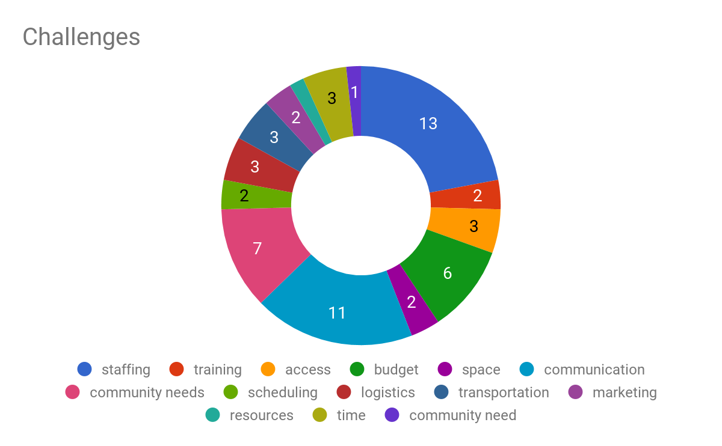
Figure 1. Challenges identified by libraries to conducting outreach work

To answer research question three, public libraries are working with a variety of community partners (see figure 2) to offer programs out in the community. In these partnerships, the library takes on the lead role in some cases and plays a supporting role in others. These partnerships embody various successes and challenges as well, including viability and sustainability.

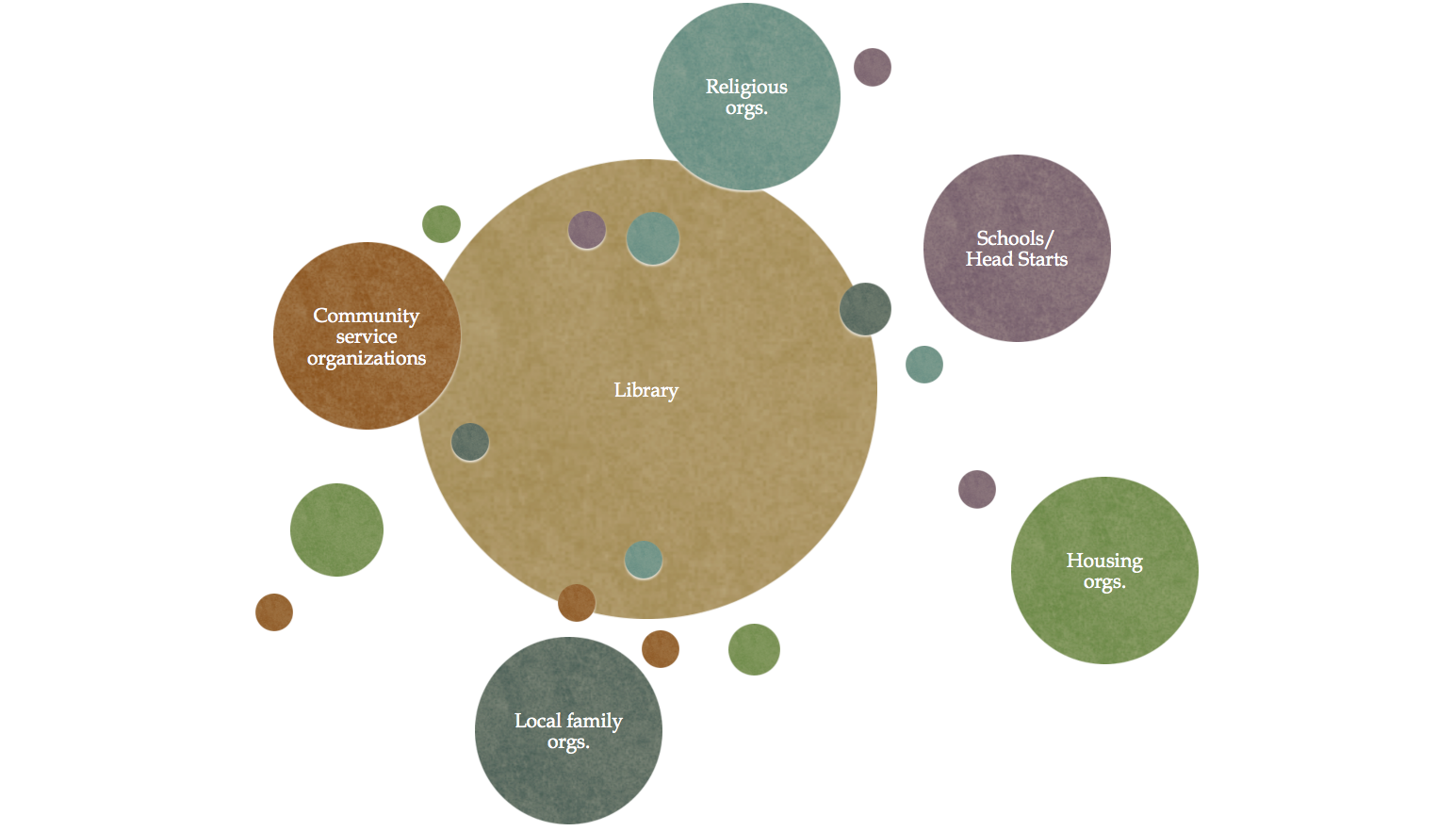
Figure 2. Constellation of community partners working with libraries in outreach programs

Discussion
These findings reveal that public libraries are making significant efforts to move outside of their walls and engage with children and families in underserved communities. Through the variety of programs they offer and the partnerships they develop, libraries are building relationships with the communities that surround them to meet the needs of families where they are.

Bronfenbrenner’s Ecological Model demonstrates the ways in which public libraries are transforming their approach to engaging children and families in underserved communities. Public libraries have traditionally existed in the exosystem for these families who are not coming into the library, not able to directly support their learning and development as a proximal process. By uncovering the fact that public libraries are moving out into the community to engage these children and families, it becomes clear that they are moving across the environmental structures described by Bronfenbrenner.

Depending on the role that the public library plays in the partnership and delivery of the program, they are transitioning to either the microsystem or the mesosystem. In a leadership role they are essentially turning the community space into a microsystem and an extension of the library, allowing the staff and resources to serve as proximal processes to directly support learning and development for the child and their family. In a supporting role in the program or service delivery, they are transitioning into part of the mesosystem, a step removed from being directly involved with the families.

Conclusion
This study has uncovered that public libraries are transforming their approach to engaging children and families in underserved communities by going outside of their walls and meeting families where they are with a variety of learning-based and family-focused programs. The application of the Ecological Model highlights that, through this work, public libraries are shifting their roles to have a more direct impact with these families. Furthermore, this model enables a better understanding of how public libraries are further establishing themselves as important and relevant informal learning environments for all families, including those who can come into the library and those who cannot. Ultimately, this baseline understanding of public libraries’ outreach efforts to families in underserved communities will provide the library profession with a broad, multifaceted understanding of current practices they can employ to reach families who are not utilizing the library.

REFERENCES
Bronfenbrenner, Urie. “Ecological Models of Human Development. In International Encyclopedia of Education, Vol.3, 2nd. Ed. Oxford: Elsevier. Reprinted in: Gauvain, M. & Cole, M. (Eds.), Readings on the development of children, 2nd Ed. (1993), pp. 37-43). NY: Freeman.
Bronfenbrenner, Urie and Evans, Gary W. “Developmental Science in the 21st Century: Emerging Questions, Theoretical Models, Research Designs and Empirical Findings.” Social Development 9, no. 1 (2000): 115–125.
Halgunseth, Linda. “Family Engagement, Diverse Families, and Early Childhood Education Programs: An Integrated Review of the Literature.” Young Children 64, no. 5: (2009).
Howard, Mary Lynn. “Growing Young Minds: How Museums and Libraries Create Lifelong Learners.” Institute of Museum and Library Services. (2013) Accesssed at https://www.imls.gov/assets/1/AssetManager/GrowingYoungMinds.pdf.
Meyers, Elaine and Henderson, Harriet. “Overview of Every Child Ready to Read @ Your Library.” (2004) Accessed at http://everychildreadytoread.org/overview-of-every-child-ready-to-read-your-library-1st-edition/.
Moxley, David P. and Abbas, June M. “Envisioning Libraries as Collaborative Community Anchors for Social Service Provision to Vulnerable Populations.” Practice 28, no. 5 (2016): 311–330.
Neuman, Susan B. and Celano, Donna C. “Worlds Apart: One City, Two Libraries, and Ten Years of Watching Inequality Grow.” American Educator 36, no. 3, (2012): 13–23.
Prendergast, Tess. “Beyond Storytime: Children’s Librarians Collaborating in Communities.” Children & Libraries 9, no. 1, (2011): 20–40.

ACKNOWLEDGMENTS
This project was made possible in part by the Institute of Museum and Library Services. Authors would like to thank the library staff and administrators for participating in the focus groups and interviews and sharing their expertise and practices in library outreach to underserved communities.

Survey will be disseminated in February 2018 and analyzed in early spring.
An examination of the survey data will likely yield an even deeper engagement with this ecological model through an examination of how libraries are determining the needs of these families and incorporating those needs into the development of the programs they deliver out into the community. In this way the libraries are creating perhaps an even more relevant and solid microsystem for these families.

