Type of Contribution: PAPER

Back to the Future: The Roles of Public Libraries in Diminishing Digital Divide in Scenarios by 2023
Zinaida Manžuch, Vilnius University, Lithuania, zinaida.manzuch@mb.vu.lt
Elena Maceviciute, Vilnius University, Lithuania, elena.maceviciute@gmail.com

Keywords: public libraries, future scenarios, digital divide, social inclusion

Introduction
During the last two decades public libraries have experienced a rapid level of computerisation and have been active players in solving issues of the digital divide. Their crucial role in diminishing it was acknowledged in different countries of the world and also in Lithuania.
As pointed out in IFLA Trends Report (2016), the combat of digital divide will remain high on library agendas; however, this work may take different forms in different countries and periods. Changes in the use of digital media and the necessity for libraries to transform their services was noted by Huysmans and Hillebrink (2008) in their analysis of the ten-year prospects for Dutch public libraries. So there is a need to rethink the public library roles in diminishing the digital divide by considering the complex nature of this issue.
In Lithuania, the large-scale projects, such as Libraries for Innovation 1 and 2, have proved to be vital for giving public access to the ICT infrastructure and to the internet to wide range of social groups and increasing the overall information literacy of the population. The impact of these projects and the public libraries themselves in diminishing the digital inequality of diverse groups was measured using complex methodology and was deemed high. However, the reflection on the future role of public libraries in diminishing of digital divide is essential for the library community to ensure that the service does not stagnate and make visible their contribution.
In 2011-2014 we conducted a project (LIBITOP) to evaluate the role of the leading libraries of the Lithuanian library network. As a part of the project, scenarios of the future development of different parts of library networks (by the year 2023), including public libraries, were created (Manžuch et al., 2013). These will be used to answer our research questions:
a) What are the roles of public libraries in diminishing the digital divide that emerge in various future scenarios?
b) What are opportunities and challenges for public libraries in diminishing the digital divide in these scenarios?

Theoretical framework
To evaluate the future prospects for public libraries in scenarios the concept of business idea, as proposed by Kees van der Heijden (2005) is used. According to van der Heijden, a business idea is how a certain organization creates value for society in general and for its customers in particular, what knowledge or internal resources (competencies) it utilizes for these purposes, and how it is done in a unique way, differently from other organisations. A business idea is an “organisation’s mental model of the forces behind its current and future success” (Heijden, 2005: p. 63). It affects scenario planning by influencing what sort of environmental changes are selected for consideration. However, scenarios may reveal whether the current business idea still works for an organization to be successful under certain scenario conditions. It means that relations between a business idea and scenarios are reciprocal – the business idea shapes the spectrum of changes considered, and the scenario’s plot provides an insight as to whether the business idea is still viable. If these mental models of an organization are recognised, a scenario planning exercise may encourage raising the questions about what the business idea should be or how it should evolve, which can itself lead to a new cycle of strategic planning. Thus, application of van der Heijden’s concept of a business idea allows us to evaluate the mental model of the roles of public libraries in diminishing the digital divide and to determine, whether this mental model is still viable.
Recognising that the digital divide is a complex phenomenon, a multilevel model of the digital divide, proposed by van Dijk (2012), is used. The model includes different levels of overall access to technology: motivational, physical, operational (skills and strategies), usage (number and diversity of applications) access. It allows us to distinguish the nature and spectrum of digital divide issues that may become relevant on the agenda of public libraries in the future. In addition, the rich model of the digital divide may offer additional opportunities for public libraries to consider.

Methods
The methods used in the investigation fall in two parts: a) the creation of the future scenarios for libraries in December 2012 to May 2013; b) the analysis of the results of the scenario creation process at the end of 2017.
The creation of scenarios involved a cycle of four seminars leading from identification of forces of influence to description of the main features in the scenarios. Here we use the scenarios for public libraries that were projected into the year 2023. They were created by 75 participants from libraries, public government bodies, observers of strategic areas, educational organizations, publishers, IT agencies and other related institutions. The seminars were recorded and analysed by the researchers immediately after each step to provide the data for the next step.
The present qualitative content analysis of the outcomes of these seminars is based on the theoretical framework combining the ways of implementing the business idea of public libraries in different future scenarios for diminishing digital divide.

Public libraries in the future scenarios
During the seminars the participants identified a number of predictable and unpredictable forces that will affect public libraries in the future. Two unpredictable forces with two possible directions dominated the discourse: the economic policy that could me either neoliberal or social welfare; the conditions of information use that could be simple of complicated. Four scenarios were created in the cross-sections:
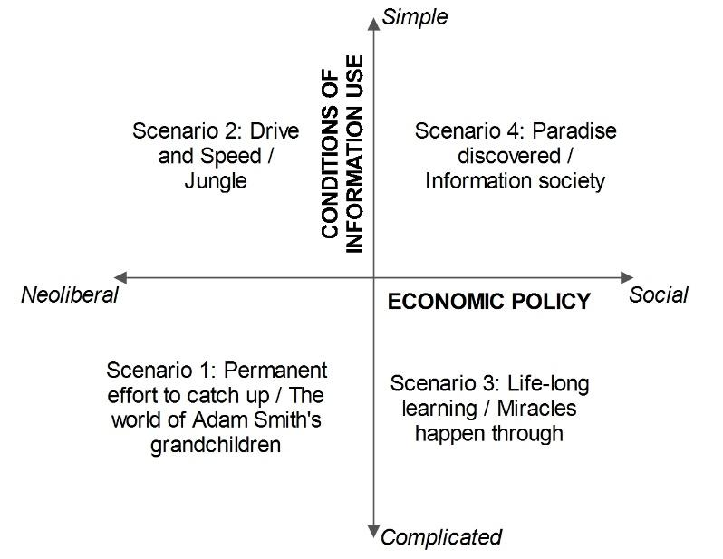
Figure 1: Future scenarios for public libraries (Manžuch et al., 2013).

Access to ICT, the availability of diverse digital content and services, their sources, prices, complexity or ease of use are in the centre of all four scenarios. Digital inequality is high in the neoliberal economic policy scenarios – Jungle (2) and The world of Adam Smith’s grandchildren (1) as the neoliberal position demands reliance on the market and a lack of government regulation, but is also relevant in the scenario Miracles happen through cooperation (3) full of open and free of charge for the users, but confusing and complicated ICTs. Even Paradise discovered (4) is not free of difficulties caused by digital abundance and resulting in isolation of individuals from the community, thus causing social exclusion of a different order.

Challenges to public libraries
In the scenarios libraries face the following challenges related to the issues of digital divide: finding their specific niche among information and cultural institutions (in all scenarios); increase their visibility in digital society (in all); being quick in learning new digital skills (in all); competing with other providers of digital services (commercial in 1, 2; free and open resources in 3, 4); proving their usefulness and effectiveness to the government and society (1, 2, 3); coping with reduced funding (1, 2); attracting people to use library services (2, 3).
Opportunities for public libraries
Opportunities are more varied according to the scenarios plot; however, some of them emerge in more than one and address different levels of digital inequality: the variety of digital technologies and resources for libraries (in all); the community need for ICT training (in all); community need for integration (in all); need for access to high quality digital services (in all); need for advice and help with digital resources (in all). These opportunities are mainly related to the digital exclusion clearly visible in the scenarios 1 and 2 and the digital divide latent in the scenarios 3 and 4. Cooperation between libraries and with other actors emerges in all scenarios as a means to increase the efficiency, effectiveness and visibility of public libraries.
Roles of public libraries as derived from the discussions of future scenarios
Educational institution: the need to increase and maintain users’ information literacy is common to all scenarios. Training in digital skills for the labour force becomes the main strategy in scenario 1. Information literacy becomes the highest priority to help orientation, navigation and critical evaluation of digital media resources in 2 and 3. In scenario 4, libraries become the centres of informal life-learning helping to use ICT for creative expression.
Community centre: in scenarios 1, 2 and 3, libraries are the main resource enabling disadvantaged groups to access ICT and digital services and increasing their opportunities in the labour market. In 3 and 4, libraries cater for cultural diversity and cohesion.
Experimental laboratory: adoption and testing of innovative ICT and digital services takes the form of delivering high quality value added services for businesses in 2, and user-friendly and accessible services in 3. In scenarios 1 and 4, the public library is used as a lab to test innovations by users themselves.
Consultancy service: this library role is related to its information and media competence. In 1, libraries create 24/7 fee-based express reference services. In 2, they help in solving copyright issues, while in 3 they assist with using e-government services. In 4, libraries consult researchers, students and population in general to solve complex problems.
Virtual service: all four scenarios emphasize the importance of remote, virtual library services available to increasingly mobile people who use other internet resources and services.
Conclusion
In all scenarios, public libraries retain their integrative and equalizing function, which seems to be one of the main features of its business idea. This idea is directly related to the issues of digital divide and social inequality. Though motivational and physical access to ICT may be solved in the emerging future scenarios of digital society, public libraries are among few institutions addressing the third and the fourth level of digital divide. They also do not lose its importance in solving economic problems of access to digital resources and services.

REFERENCES
Dijck, Jan A.G.M. van. 2012. “The evolution of the digital divide: The digital divide turns to inequality of skills and usage”. In: J. Bus et al. (eds.). Digital enlightenment yearbook 2012, (pp. 57-75). Amsterdam: IOS Press.
Hejden, Keys van der. 2005. Scenarios: The art of strategic conversation. 2nd ed. Chichester: John Wiley > Sons, Ltd.
Huysmans, Frank, Hillebrink, Carlien. 2008. The future of the Dutch public library: ten years on. https://www.scp.nl/dsresource?objectid=e226ca56-d730-4bd5-95b1-8bbfcf26bbcb&type=org
IFLA. 2016. Riding the waves or caught in a tide? Navigating the evolving information environment. The Hague: IFLA. (IFLA Trend Report). https://trends.ifla.org/insights-document
Manžuch, Zinaida, Macevičiūtė, Elena and Sadunišvili, Renata. 2013. Lietuvos valstybinės bibliotekų reikšmės ir apskričių viešųjų bibliotekų ateities plėtros scenarijų tyrimas (Investigation of the future development scenarios of Lithuanian libraries of state importance and county public libraries. Vilnius: LiBiTOP.

ACKNOWLEDGMENTS
The authors would like to thank the European Social Fund Agency for its generous support to the project LiBiTOP, which enabled us to carry out the first library scenario planning research in Lithuania and the Lithuanian Research Council that allowed us to research the complexities of digital inequalities in the project “The Stimulation of Digital Reading as a Means of Reduction of the Digital Divide”.

