Type of Contribution: PAPER

Whose Korea?: Intercultural Encounters Mediated
Through YouTube Videos

Nahyeon Kim, University of Toronto, Canada, nh.kim@mail.utoronto.ca
Nadia Caidi, University of Toronto, Canada, nadia.caidi@utoronto.ca
Niel Chah, University of Toronto, Canada, niel.chah@mail.utoronto.ca

Keywords: virtual community, YouTube, information ground, intercultural competence, intercultural engagement

Introduction
Many of us have encountered YouTube videos that introduce us to other cultures, be it Korean, Brazilian, or Croatian culture. These videos are often entertaining and informative, even when produced by non-natives of the cultures represented. Why is that so? How do these videos operate and what makes them popular? At the heart of our research is a particular genre of ‘intercultural encountering’: YouTube videos/channels, and the cross-cultural engagement enabled by these media. We examine selected YouTube channels and videos to better understand their characteristics and audiences, along with the performed informational role of these channels. Our findings point to several functions played by such videos: from informing to entertaining, developing intercultural competence, and creating a space for intercultural communication (information sharing, reflecting about one’s own culture, and co-creating culture together). We point out the potential for YouTube (and other emergent platforms) to act as information grounds for intercultural communication and for facilitating intercultural competence in our increasingly globalized world.

Background and Context
As of 2018, YouTube is the 2nd most visited site (Alexa 2018) where millions of hours of videos are watched daily (YouTube 2017). YouTube is a lively space where viewers do more than just watch videos: they share their experiences, opinions, and interact with others from all over the world (Burgess and Green 2013). YouTube has given rise to a class of video content creators and producers that make a living from viewership, ads and sponsorships. The most successful among them are followed by millions thus creating a virtuous circle that attracts even more viewers, generates more revenue, and expands the online community. This research considers how this virtual space operates, specifically as geared towards delivering cultural information and knowledge.

Theoretical framework
We draw upon various concepts in human information behavior to make sense of the nature of the engagements taking place in the context studied, such as small worlds (Chatman 1991), everyday life information seeking (Savolainen 1995) and information grounds (Counts and Fisher 2010; Pettigrew 1999) as a means of apprehending how both content producers and consumers use, seek and share content.
We also introduce the concept of ‘encounter’ as theorized by Ahmed (2000) as it accounts for the relational and contextual factors that shape engagement and the cross-cultural dynamics at play in a setting like the one examined here. Ahmed understands the encounter to be not just between people (in this case, content producers, viewers, commenters), but also between texts (here, videos, captions, comments), readers/contributors, and even nations and cultures. Following Ahmed, we inscribe the encounter, rather than the Korean identity itself, as the point of departure for our examination. Moreover, Ahmed’s conceptualization of the encounter as a method allows us to consider “the production of meaning as a form of sociality. That is, meanings are produced precisely in the intimacy of the ‘more than one…’ by ‘coming together’ at a particular time and place” (Ahmed 2000, 15). In using encounters as the lens and space through which we examine the YouTube channels and the interactions stemming from them, we start unpacking the social relationships brought into the encounter through the participants, the texts/videos, and stories shared on the platform.

Methodology
We selected two popular channels dealing with Korean culture that are operated by non-Koreans. Our research aims to understand how people from different cultures interact around the represented topic (experiencing Korean culture when one is not Korean), how these channels facilitate intercultural exchange and meaning making, and how social relationships are developed along the way. The two YouTube channels selected are popular with non-Koreans interested in Korean culture: “Korean Englishman” (KE) and “Simon and Martina” (SM). These channels make videos that introduce Korean culture through their own unique lens. Both channels are operated by non-Koreans (from England and Canada respectively) who have lived in South Korea for extended periods of time. In producing videos prolifically, both channels approach Korean culture with great humour, respect, and mass appeal, garnering millions of views and thousands of comments. From each of the two channels, we then selected four popular videos with high views and high comment count. An iterative thematic analysis of the comments was conducted for each video. We adapted Madden et al.’s (2013) classification scheme for coding YouTube comments.

Results
We report here on the following three dimensions: linguistic distribution, specific types of interactions (observed in the comments section), and intercultural negotiations.

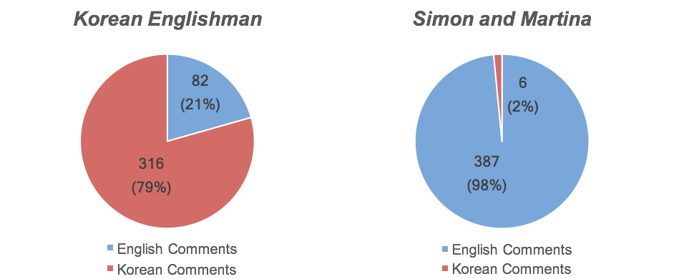
Figure 1. Analysis of comments by language

While both channels address Korean culture from the creators’ perspectives (as outsiders), they differ in that one (SM) features the hosts as talking heads mostly, while the format of the KE videos consists of immersing (predominantly) English guests into a Korean practice (culinary or otherwise) and getting their feedback. Our analysis indicates clear variations between the two channels. For KE, comments were predominantly in Korean (79.4%) vs. in English (20.6%). By contrast, 98% of the comments for SM videos were in English (vs. 2% in Korean). SM’s international audience seemed to prefer English for comments on the videos, and for sharing own cultural experiences. In the KE case, the overwhelming use of the Korean language suggests that South Korean viewers were engaged heavily in the consumption of the content, and in debating how their culture and practices were seen through the eyes of the non-Korean content producers.

We also noted a lively engagement with the topics in each video, as shared in the comments section. The figures below show how each video fared under Madden et al.’s (2013) coding categories for comments (e.g., Information, Impression, Opinion, etc.). Indeed, the videos seem to serve as a platform for greater discussion and for community-building around the ‘making’ of the videos as much as the cultural experiences. Beyond liking a video, we observed a continuum of engagement with the videos and their subject matter, which included: information sharing, storytelling, reflections about the video itself, references/comparisons to other videos in the series, side conversations among viewers about a related topic. The videos themselves become triggers for a broader conversation, or the “encounter” in Ahmed’s sense that is the departure point for meaning making and relationship-building.

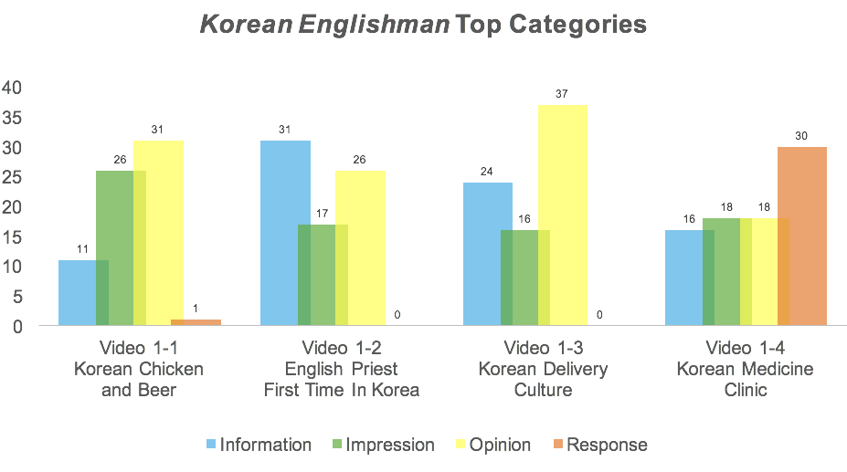
Figure 2. Analysis of comments by category of interaction for Korean Englishman

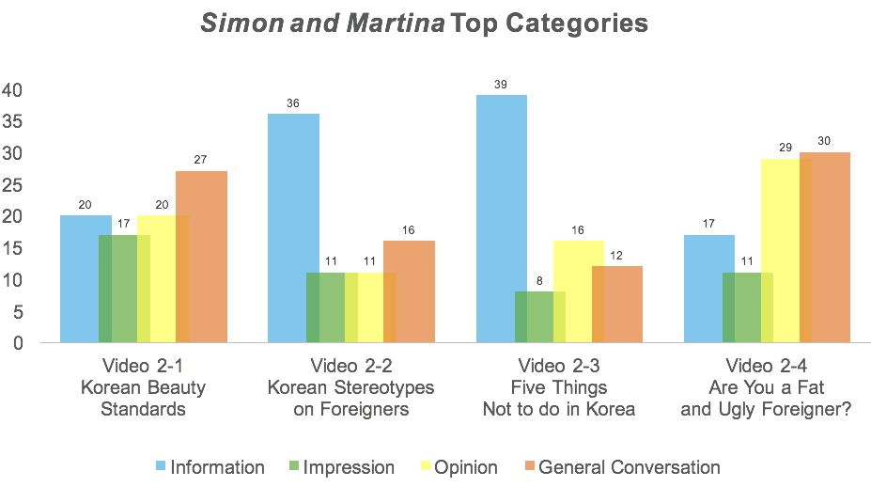
Figure 3. Analysis of comments by category of interaction for Simon and Martina

Our findings also point to the intercultural competence (shaped through interactions with the other) as well as to the co-creating of culture. Testimonials from Non-Korean viewers about how information they gleaned from these channels (both videos and associated comments) helped them during their travel to Korea indicate the level of trust assigned to these encounters. Also noted are instances where the non-Korean viewers started making use of the Korean terms as part of the encounter; and culminating in one KE video to the adoption by the viewers of a new term ("chimaek-ing") that was initially coined humorously by the host but was quickly taken over by the audience and reprised in subsequent videos. The term became an inside joke and a co-creation of the KE community. It established and solidified social relationships (those in the know and those that were not).

Discussion and Implications
As can be seen, it seems that a major reason for the popular success of these videos involves the YouTubers’ ability to capitalize on their lived experiences in Korea and their role as cultural bridges or cultural translators. Their unique stances make their videos widely appealing for a range of viewers, from the tourist planning to travel to Korea, the business person vying to understand the Korean public, to the schoolteacher researching a class project. The content creators’ British and Canadian backgrounds (respectively) along with their intimate knowledge of (and affection for) Korea are elements that allow them to function as effective cultural bridges.
It would be erroneous however to surmise that these YouTube channels are providing casual entertainment as a sole purpose of their channels. Rather, our findings suggest that the YouTube platform can be read as an encounter where intercultural literacy and understanding can be fostered by design.

As the 2nd most visited website globally, it would be fitting for information professionals to pay more attention to how social media platforms like YouTube channels foster virtual communities, facilitate new forms of intercultural engagement and cultural learning through story-telling and experiential learning. This can lead information professionals and others to adapt their own design to account for diversity, inclusivity, and community engagement.

REFERENCES
Ahmed, Sara. 2000. Strange encounters: Embodied others in post-coloniality. London & New York: Routledge.
Alexa. 2018. “The top 500 sites on the web.” Accessed Jan 10, 2018. http://www.alexa.com/topsites.
Burgess, Jean, and Joshua Green. 2013. YouTube: Online video and participatory culture. John Wiley & Sons.
Chatman, Elfreda A. 1991. "Life in a small world: Applicability of gratification theory to information-seeking behavior." Journal of the American Society for information science 42, no. 6: 438.
Counts, Scott, and Karen E. Fisher. 2010. "Mobile social networking as information ground: A case study." Library & Information Science Research 32, no. 2: 98-115.
Madden, Amy, Ian Ruthven, and David McMenemy. 2013. "A classification scheme for content analyses of YouTube video comments." Journal of documentation 69, no. 5: 693-714.
Pettigrew, Karen E. 1999. "Waiting for chiropody: contextual results from an ethnographic study of the information behaviour among attendees at community clinics." Information processing & management 35, no. 6: 801-817.
Savolainen, Reijo. 1995. "Everyday life information seeking: Approaching information seeking in the context of “way of life”." Library & information science research 17, no. 3: 259-294.
YouTube. 2017. "Press - Youtube" Accessed January 10, 2018. https://www.youtube.com/yt/press/statistics.html.

https://www.youtube.com/user/koreanenglishman
https://www.youtube.com/user/simonandmartina

