Type of Contribution: PAPER

Research Methods for Conducting School Library Causality Research

Carol Gordon, Gordon Consulting, United States, drcarolgordonconsulting@gmail.com
Xiaofeng Li, Rutgers University, United States
Abstract: This proposal presents a constructivist theory of learning to support the concept of the Essential School Library that facilitates substantive learning outcomes. The proposal explores: Methods for conducting causal school library research: Sample size and representativeness; the construction of survey questions that accommodate statistical analysis; and the role of digital access in selecting causal research methods.

Keywords: School library research; Causality research; Digital equity; Measuring access

Theoretical background
Learning outcomes are emerging as the litmus test for viable empirical research in the school library field [AASL, 2014]. The theoretical framework for this proposal derives from constructivist learning theory [Piaget, 1928; Dewey, 1943; Bruner, 1960] that defines learning as making meaning from information to build a personal knowledge system. The components of a school library, i.e., facility, collection, staff, programming, and budgeting, are traditionally defined as inputs for administration and management of libraries. Fig. 1 [Gordon, 2017] presents an emerging lexicon that re-defines these inputs as tools for designing constructivist learning experiences that facilitate robust learning outcomes. “Facility” becomes a physical and virtual learning environment in which information technology is integral. Print and digital resources are dynamic information resources rather than fixed collections. All library staff, including volunteers, work as an instructional team and all programmatic events are learning experiences. Budgeting becomes fund development when librarians build influence with school administrators, the community-at-large and politicians to secure the resources they need [Hartzell, 1994]. A new lexicon points to the design and implementation of instruction that results in robust quality learning outcomes, e.g. projects, displays, or performances that represent critical thinking, problem solving, and creativity. When this terminology is operationalized, libraries become “essential.”

Learner Outcomes

1. Learning Environment
[Library facility input]
2. Information technology

3. Print & Digital Information Sources
[Collection Input]

4. Instructional Team
[Staff Input]

5. Instruction
[Programming
Input]

6. Fund Development
[Budget Input]

Fig 1. A New Lexicon for the Essential School Library [Gordon, 2017]
The seminal question for the proposed presentation is: How do researchers design empirical, causal studies that measure the success of teaching and learning in the essential school library?
Research Questions
In 2013 the Massachusetts legislature formed a special commission to conduct research on the status of school libraries in the state, resulting in The Massachusetts School Library Study: Equity and Access for Students in the Commonwealth [Gordon & Cicchetti, 2018]. The purpose of the research was to determine the status of school libraries, as measured by their traditional components. This presentation proposes to use the design, analysis, and findings of the Massachusetts study to explore three research questions that could inform causal research methods that show how school libraries contribute to and enhance teaching and learning.
1. How did the Massachusetts study overcome barriers to establishing a representative sample of Massachusetts’ school libraries?
2. How did the construction of survey questions affect statistical data analysis?
3. Why is equitable access to digital technologies and information a critical
factor in school library causal research?
Approach
The American Association of School Librarians [AASL], the national school library association that sets standards for teaching and learning in school libraries, issued a white paper that proposes a national research agenda that demonstrates the positive influences of effective school librarians and quality school libraries on student learning. The paper reviewed over 25 correlational studies of school library programs and school librarians’ activities. “The results of these studies suggest that complementary research should be conducted to establish a causal relationship between the work of effective school librarians and the creation of motivated, engaged, and agile learners.” [AASL, 2014, p. 3]. One of the goals of the proposed agenda guides this proposal: To “Propose a progression of research methods and projects that will support theory building, exploratory research, and demonstration research.” [AASL,
2014, p.3]
Methods
A content analysis of the Massachusetts study includes:
1. Analysis of the collection of school library statistics through interviews with Massachusetts Board of Library Commissioners, School Library Association, Library System and the Department of Elementary and Secondary Education and examination of their documentation of school libraries to make inferences that can inform sample size and selection.
2. Analysis of statistical test findings of access to the six school library access indicators [fig. 1] and corresponding survey questions to determine trends and patterns in the design of the survey and consequences for the construction of a survey instrument.
3. Determination of the role of equitable digital access to school library resources and services and exploration of existing research methods that measure access.
Results
Question One. There were 722 survey responses from which a sample size of 521 was determined. 94.5% were public school librarians from suburban [63.9%], rural [10.9%], and urban [24.8%] districts. Participation of public and private schools from three district types was commensurate with their corresponding populations.
The most recent data on the number of school libraries were collected in 2007, making it difficult to establish an adequate sample size. Researchers calculated a range of the sample size based on 22%. The following observations and inferences were made.
- The number of valid surveys was 521, which is 43% of the 1,226 school libraries that we know were in existence prior in 2007.
- We know there were library closings since 2007, so the current number of school libraries is less than 1,226.
- We know that population of school libraries is not less than 722 since each response represented a unique school library. 22% of that population is 73.9%.
- We can conclude that the range of the number of school libraries is more than 521 [43%] and less than 1,226 [73.9%].
- Statistically the sample does not differ from the true population by more than 3.2% so it has a strong level of representativeness.
Question Two. The analysis of responses to survey questions focused on those questions that qualified for statistical analysis, resulting in a chart that shows these questions and the specific statistical tests that were applied to each. These tests compared school libraries’ resources and services across three district types: urban, rural, and suburban. A preliminary chart is supplied in Table 1.
Table 1. Statistical Tests Used for Determining Access to Staffing, Library, Resources, Funding and Instruction
Access Category | Survey Item-Access | Statistical Test
Staffing | School Librarian | Pearson’s CHI Square
 | FTE Support Staff | Pearson’s CHI Square
School Library | Flexible Schedule | Pearson’s CHI Square
 | Hours per week library open | ANOVA
 | Days per year library closed | ANOVA
Resources | Automated circulation system | Pearson’s CHI Square
 | Electronic, remote access to catalog | Pearson’s CHI Square
 | Print collection size | ANOVA
 | Number of added materials | ANOVA
 | E-Books | ANOVA
 | Alternative reading materials | ANOVA/Tukey Post Hoc
 | Interlibrary Loan | Pearson’s CHI Square
 | DVDs | ANOVA
 | Videocassettes | ANOVA
 | Audiocassettes | ANOVA
 | Video streaming | Pearson’s CHI Square
Funding/Subsidized Resources | Budgetary allocation | ANOVA  Game Howell Post hoc
 | State funded electronic resources | Pearson’s CHI Square
 | Membership in Massachusetts Library System | Pearson’s CHI Square
 | Commonwealth E-Book Collection | Pearson’s CHI Square
 | Locally funded collection | ANOVA
Library Instruction and Help | School library website | Pearson’s CHI Square
 | Instruction on school library website | Pearson’s CHI Square

Pearson’s CHI Square accounts for all four of information technology data points from the survey shown in Table 2, which is a partial display of the data.
Table 2. Statistical Tests Used for Determining Access to information technology

IT Access | Type of Test
1. Comparison of  bandwidth | Pearson’s CHI-SQUARE | Urban/Suburban  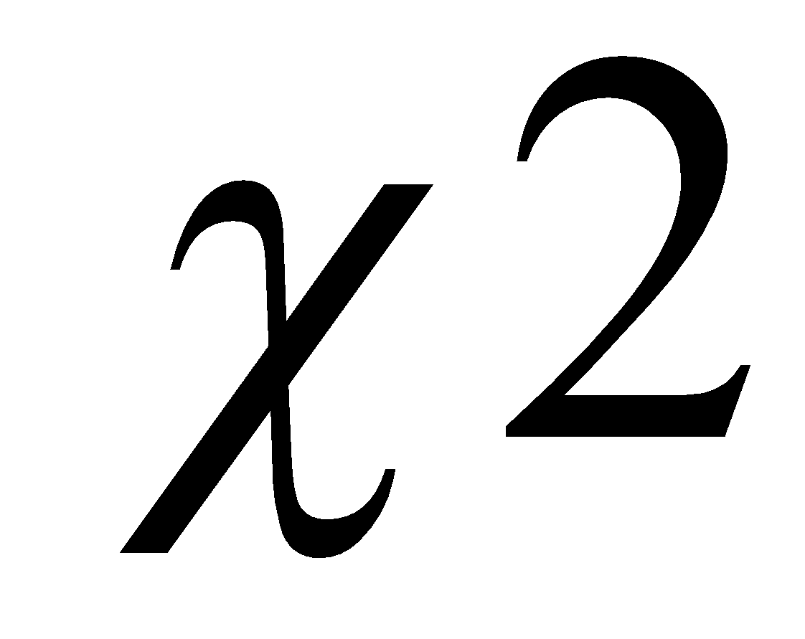(1) =7.41, p = .006
2. Student Internet Access | Pearson’s CHI-SQUARE | Urban/Suburban  (1) =5.60, p= .02.
3. IT Access in the library | Pearson’s CHI-SQUARE | Urban/Suburban  (1) = 5.60, p = .018.
4.Library or Technology Director | Pearson’s CHI-SQUARE | (1) =15.37, p<.001.
 |  | (1) =18.96, p<.001.
5. One-child, one- computer policy | Pearson’s CHI-SQUARE | Urban/Suburban  (2) =2.73, p = .26  Rural/Suburban  (1) =0.54, p = .47.
n=521

Analysis of these charts will focus on how survey questions can be designed to qualify for a wider range of tests. This analysis will also focus on findings to determine how the trends in measuring the six school library inputs for resources and services inform the construction of survey questions.
Question Three. A literature review will indicate the types of tests and analysis currently used to measure equitable access, or lack of it, to school library resources and services. It is anticipated that the most difficult input to measure is instruction. The presentation will explore the single case experimental design for educational research as a viable methodology for accommodating the effects of constructivist teaching methods on small but representative samples of learners.

References
"American Association of School Librarians National Research Forum. 2014. Causality: School Libraries and Student Success [CLASS]. Chicago, IL: American Library Association. Retrieved 20 April 2018 from Http://www.ala.org/aasl/sites/ala.org.aasl/files/content/researchandstatistics/CLASSWhitePaperFINAL.pdf." Causality: School Libraries and Student Success [CLASS]. Chicago, IL: American Library Association. 2014. Accessed April 30, 2018. http://www.ala.org/aasl/sites/ala.org.aasl/files/content/researchandstatistics/CLASSWhitePaperFINAL.pdf.

Bruner, Jerome. The Process of Education. Cambridge, MA: Harvard University Press, 1960.
Dewey, John. The School and Society. IL: University of Chicago Press, 1943.

Gaver, Mary. Effectiveness of Centralized Library Service in Elementary Schools. New Brunseick, NJ: Rutgers University Press, 1963.

Gordon, Carol A. "The Essential School Library." Academia.edu. Accessed February 1, 2017. https://www.academia.edu/31029633/The_Essential_School_Library.

Hartzell, Gary N. Building Influence for the School Librarian. Professional Growth Series. Worthington, OH: Linworth Publishing, 1994.

Research and Statistics about Libraries.”. 2016. Accessed April 30, 18. https://www.lrs.org/data-tools/school-libraries/impact-studies/.

O'connell, James J. “Horace Mann’s Influence on School Libraries in Massachusetts.”. MA diss., University of Massachusetts, 1934. Anhearst, MA: University of Massachusetts, 1934.

Piaget, Jean, and E. Cartalis. Judgment and Reasoning in the Child. London: Routledge & Kegan Paul, 1969.

