Paper

“Can I ask that?”: Silence, respectability and geographies of fear among Black and Latina Tween information seekers
Amelia Gibson, The University of North Carolina at Chapel Hill, United States, angibson@email.unc.edu

Information seeking, Gender, Race

Introduction
The social norms and practices that Black and Latina girls and women have developed to ensure their physical, social, and emotional safety (Valentine 1989) also shape their information seeking behavior (Sobieraj 2017). The freedom to seek information –– especially information about health, wellness, and the body –– is not universal. In practice, any individual’s ability to understand the need for information, know the best place to find that information, have access to the necessary resources, and to have the freedom and wherewithal to access those resources depends on social positioning, social power, and economic power. Additionally, the ways that individuals and communities normatively interact with information –– the ways that they form the information values and cultural values embodied by their epistemologies, ontologies, and pedagogies –– can depend on subjective and objective social positioning, as well as identity (Belenky 1986). The paper briefly describes some of the ways that Black and Latina American teen girls perform respectability and virtue while seeking information about health and wellness, how the perceived responsibility to do so limits their information seeking, and discusses a few implications for library and information science (LIS).

Theoretical Frameworks
This study uses Valentine’s (1989) concept of women’s geographies of fear to examine teen girls’ information practices related to health, wellness, and self. It also builds on Chatman’s (1999) theory of life in the round to examine intersections of gender, race, and environment, and their combined role in the construction of personal (perceived as being determined by self) and public (perceived as being determined by community) geographies of information seeking among young black women. For many young black women, information seeking is, like many other behaviors, negotiated among conflicting needs, resources, and socially imposed limitations. Often, their ways of knowing and seeking are not acknowledged as valuable or “correct” in discussions on information literacy and poverty. Previous studies of Black youth from homes with low incomes have suggested that discourses addressing sexual health and safety of Black girls often assume them to be particularly vulnerable, and sexual health education for this group often equates respectability and moral good with sexual restraint (Froyum 2007; Froyum 2009). This suggests that Black girls might not benefit from discussions about sex-positivity an openness to the same degree as their white counterparts, and implies that details of reproduction is “none of their business.”

Research Questions
This abstract outlines preliminary findings of part 1 of this two-part study. It addresses the following research questions specifically:
- How do fear and respectability influence participants’ information seeking behaviors and source selection?
- In what ways did participants perform virtue and respectability as they sought information about health and wellness (and more specifically, sex and sexuality)?

Methodology
This mixed-method study engages a community based participatory approach to examining the construction of personal geographies of information seeking of six young Black and Latina American women (ages 12-15 years). Six participants participated in weekly focus group and health information literacy sessions, and completed a written diary between January and May of 2017. Participants were also asked to complete a questionnaire prior to the first focus group.

Weekly focus groups lasted approximately 1.5 hours. Focus groups discussions centered on participants’ information needs, information seeking strategies, and where, when, and why girls engage in information seeking on the given topic. Participants were encouraged to seek information using Chromebooks, tablet devices, and on their cell phones during focus group sessions. Focus group sessions were audio recorded and transcribed by a third party.

Participants were recruited from a local youth organization in an urban, southeastern American city. Flyers and parent permission forms were distributed to potential participants. Each participant received a $25 gift certificate and a Kindle tablet device upon completion of the study.

Inductive analysis and constant comparative methods were used to discover emergent themes related to participants’ personal information seeking geographies. Each participant was asked to complete 10 minutes of diary entries per week. Entries were used as prompts for focus group discussions.

Findings and Discussion
While participants cited a number of motivating factors for information seeking and source selection, there was evidence that fears related to physical safety and social standing played a role in their development of information seeking strategies. These findings became apparent on the following two levels: in interactions between the researcher and the participants, and in participant descriptions of information behaviors.

Performative Respectability
Initial interactions between the researcher and the participants were frequently performative, and reflected participants’ assessments of the researcher’s information values. For example, when asked questions about how they learned about a topic, the girls initially responded with answers that that they calculated to be “correct.” For example, in order to learn about whether their drinking water was safe, they would need to consult with Ph.D.s who studied water quality. In order to learn about personal safety at school, they would need to consult a website from the federal government. In both of these instances, girls’ judgements of authority outmatched their search skills. When asked to find a high quality source of information about water quality, they collectively agreed upon the website for Deer Park brand of water (because it was the first Google result – an ad), and a website from the National Safety Council (nonprofit organization) on school safety (again, first google result). After 20-30 minutes had elapsed within each session, they began to relax, and moved on to other sources of information – parents and grandparents, friends, Google, and Instagram. Participants were also asked about social media use, and other questions found on pre-focus group questionnaires. During these initial period, a few participants denied using social media on the grounds that it was “trouble” or “drama” or that they were not old enough to use it, only to refer to use later in the same (or later) focus group sessions. Likewise, they would question their need to know about issues related to boys, relationships, or sex. One (14 year old) girl stated, 5 minutes into the final focus group session that she didn’t need to know how to find out about sex because “that’s why we have parents.” Ten minutes later, when asked to draw her information horizon, she noted that she would ask her friends first (see Figure 1). Over the course of the study period, the time spent on performative respectability reduced from 30 minutes per session to 10 minutes per session.
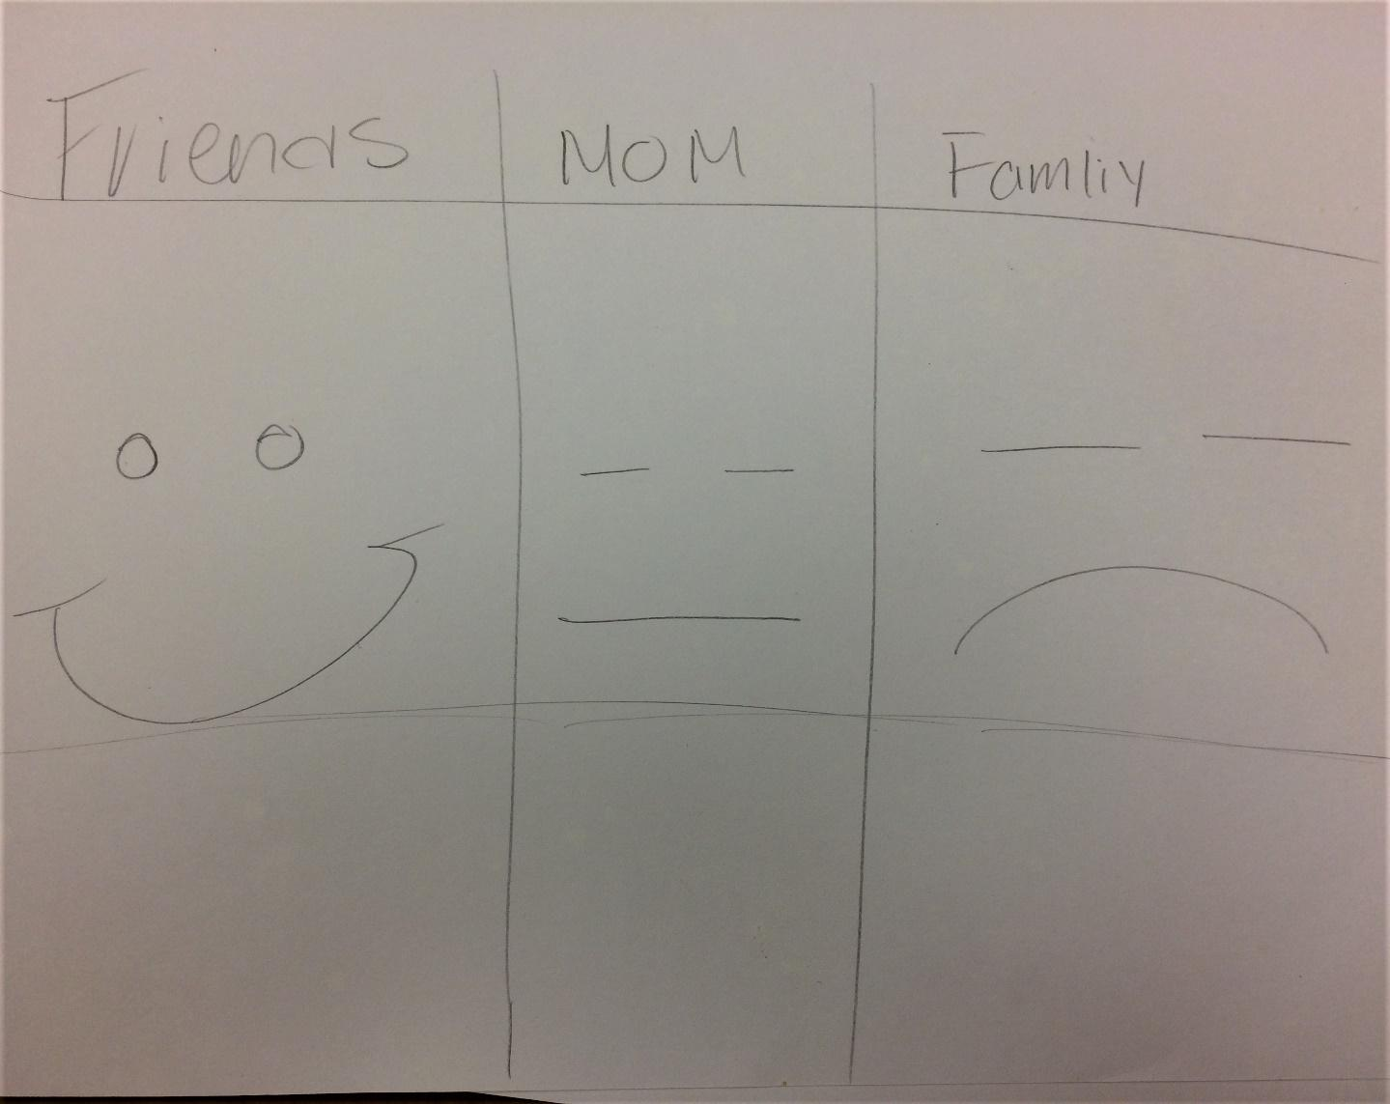
Figures 1. Source preferences, Participant 1

Fear as a motivator
Girls cited a number of motivating fears in their descriptions of information seeking. High among them were fears about social media use and personal safety. “People crazy these days” said one participant as she explained why she didn’t make YouTube videos. They cited fears of strange men or older boys finding them, physical and sexual violence, discovery of personal secrets leading to loss of social standing, and hacking resulting in loss of access to accounts (mostly by friends and people they knew). Their fears were very similar to intentional threats cited by Sobieraj (2017): physical intimidation/violence, restricted access to the web, doxing, discrediting, and public shame. Their described information seeking strategies were intended to help them circumnavigate these threats. In several cases, participants cited fears related to disclosure as more important than information quality. In figure 2, a participant said that she would go to her health teacher last, despite being sure that she would provide the “right” answer. She cited her friends first, although she noted verbally that they might not know what she wanted, and said that she would go to her “parents (her aunt – not her mother)” second.

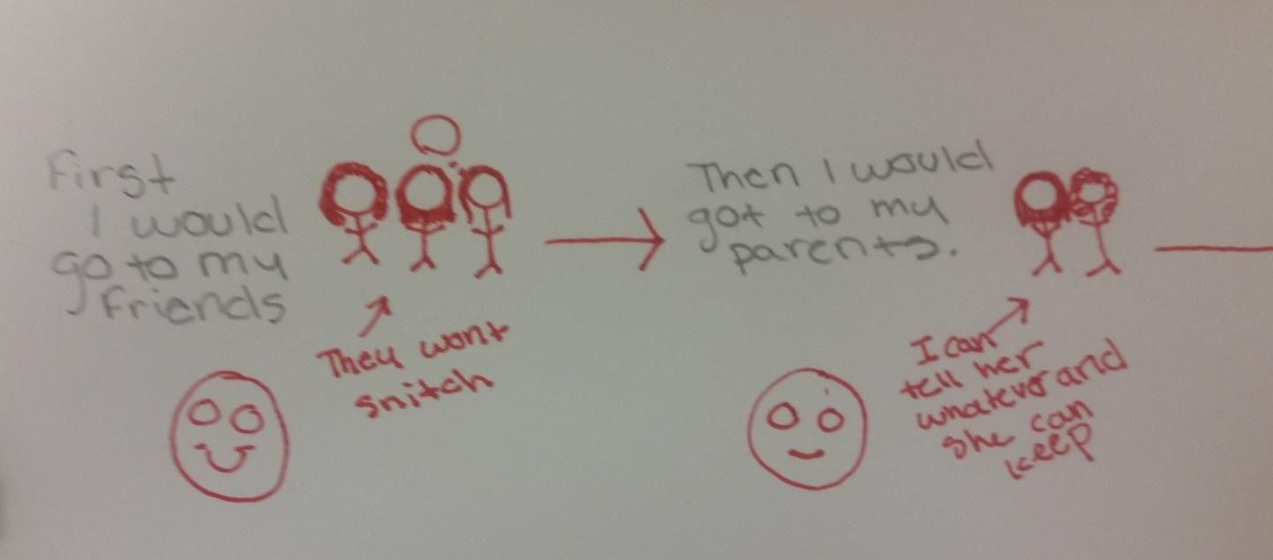
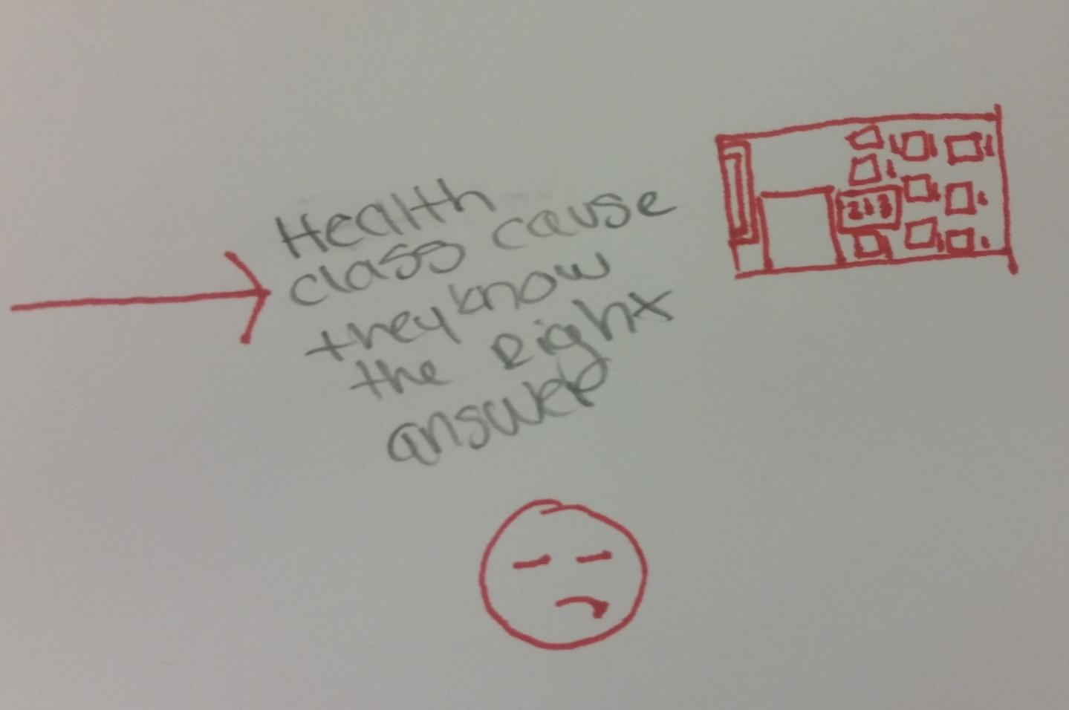
Figure 2. Source preferences, Participant 2

Instagram and Google seemed to be the most frequently used search platforms used to look for information about the study topics. The greater the risk for physical harm, the more likely they were to cite a parent as a good source of information.

Discussion
A growing body of research acknowledges the influence of social context on information values (i.e., understandings of what information is, and what information is important) and our information-related social norms (Jaeger and Burnett 2010). These findings suggest that information values and information seeking norms tied to identity –– race, ethnicity, gender, ability, and to some extent, social class –– include social codes related to respectability and fear that shape girls and women of color’s information behaviors. Sobieraj (2017) writes, “Just as inhibited use of public spaces is a spatial expression of gender-based oppression, inhibited use of chat rooms, social media platforms, blogs, vlogs, and online gaming must be understood as a digital expression of these power dynamics” (p.2). These findings differ, in that they suggest that girls’ internalized understandings of gender can pre-empt information seeking behavior, making them less likely to seek information, even in the absence of overt threats. They also emphasize the importance of trust and relationship-building in providing information to girls in these age and racial/ethnic groups.

REFERENCES
Belenky, M. F. 1986. Women's Ways of Knowing: The Development of Self, Voice, and Mind. Basic books.

Chatman, Elfreda. 1999. A theory of life in the round. Journal of the Association for Information Science and Technology 50: 207-217.

Jaeger, Paul, and Burnett, Gary. 2010. Theory of Information Worlds. Routledge

Froyum, C.M., 2007. “’At Least I'm Not Gay': Heterosexual Identity Making among Poor Black Teens”. Sexualities, 10: 603-622.

Froyum, Carissa. 2009. Making ‘good girls’: sexual agency in the sexuality education of low-income black girls. Culture, Health & Sexuality 12: 59-72.

Sobierak, Sarah. 2017. “Bitch, slut, skank, cunt: patterned resistance to women’s visibility in digital publics.” Information, Communication & Society, 1-15.
https://doi.org/10.1080/1369118X.2017.1348535

Valentine, Gill. 1989. “The geography of women’s fear.” Area 21: 385-390.
http://www.jstor.org/stable/20000063

ACKNOWLEDGMENTS
The author thanks the participants of this study for their time, effort, and vulnerability. This project was funded by an Eleanor M. and Frederick G. Kilgour research grant through the University of North Carolina at Chapel Hill.

