Type of Contribution: POSTER

Creating information awareness on LIVING concepts in the twilight years – a study of senior living communities in India

Sharmila Ghosh, Consultancy Libraries & Information Services, India, milaghosh@gmail.com

Keywords: senior living communities, informed decision-making, care&share, assisted living, senior citizens' information services (SCIS)

Introduction
With the gradual breakdown of joint families and the nuclear family becoming more popular as a way of life in India, the last ten years have seen a rapid increase in development of infrastucture and services towards a life of dignity and comfort for the old age senior citizen population in India. Advances in medical services with extended life spans and years of post-retired living has evoked, directly and indirectly, serious challenges within the very framework of our society and community.
This study, while focusing on the increasing availability of community-sponsored senior living facilities and conveniences, aims to create the much-needed information awareness among the elderly, in order to generate an optimistic and encouraging scenario towards spending the twilight years joyfully and meaningfully.

Research questions
- The first and foremost is HOW to convince our target audience WHY they deserve to live a life of independence, peace and dignity and hence seek to explore available options
- The next challenge is to lead them to a solution-based, single-window information platform to enable them to take well-informed decisions (with adequate clarity of thoughts) about the transition to a community-supported living space,.
- The third and most important issue is to collect, customise and collate social, economic, statistical, legal, medical, financial and cultural information for anytime access / reference.
Our team, comprising of gerontologists, knowledge workers, community self-help groups, visited some of the established senior communities, collected primary data, and compiled towards relevant research for selective sharing among those considering moving into senior living homes.

Methodology
Three groups with 125 senior citizens in each group, have been selected – for personal interviews and opinion polls. The questionnaire method was not considered to be viable.
(A) those living with their independent / married children | (B) those living alone by choice or convenience, with external support | (C) those compelled to live alone on situation or abandoned
- First step: identifying individuals/families and advocating senior living concepts and possibilities. Organise workshops and coffee table sessions at senior citizens' activity centres with short talks by agecare activists, health care workers and information support groups.
- Second step: identifying events with participation of target audience where pamphlets and brochures containing relevant information (available from Government, social welfare departments, nonprofit/self-help groups, functional senior living communities) will be distributed.
- Third step: follow-up activities by knowledge workers and agecare support groups, virtual tours by managers of senior living communities, meetings and door-to-door checking. Finally, those showing holistic interest and are ready to explore, will be taken on site visits to check on reality situations.

Research Results
Group-A (living with independent or married children): 52% ready to move to retirement homes, 34% averse to any changes in living mode, 14% are indecisive and confused, lack of clarity
Diagram 1
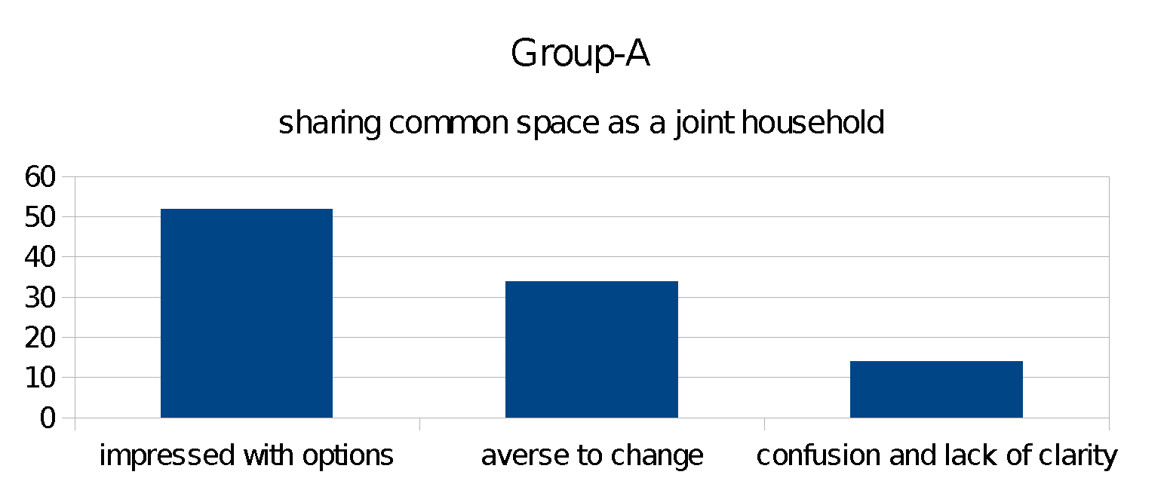
Group-B (living alone by preference or convenience): 45% interested but not keen to shift, 40% prefer status quo as long as they can, 15% expecting children or other family to take a decision
Diagram 2
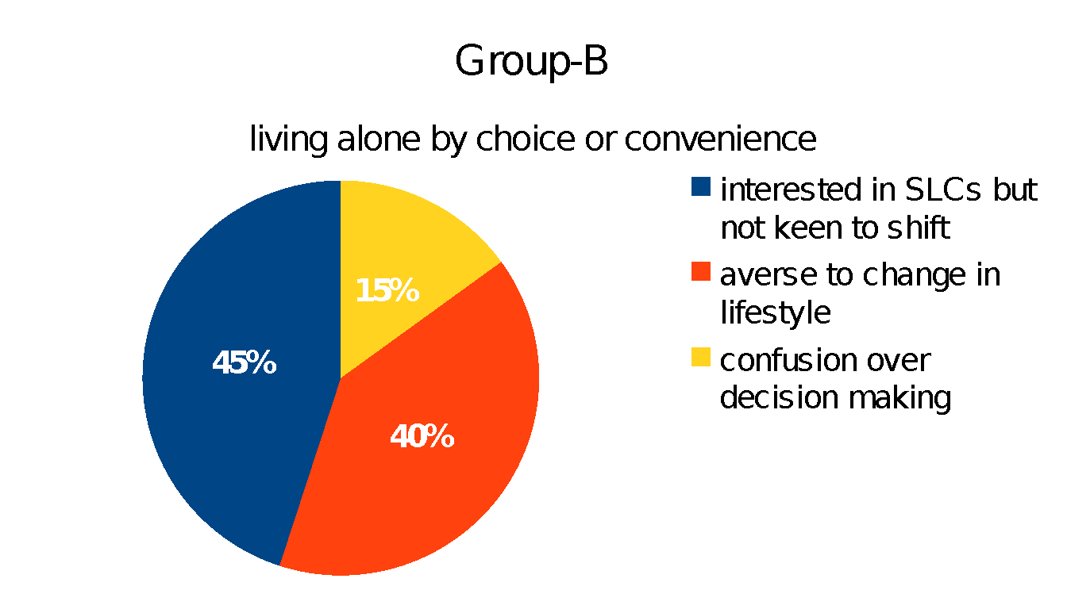
Group-C (alone by situation): 76% eager or curious to learn about community support, 14% want to continue status quo as long as they can, 18% reluctant to move away from their ancestral homes
Diagram 3
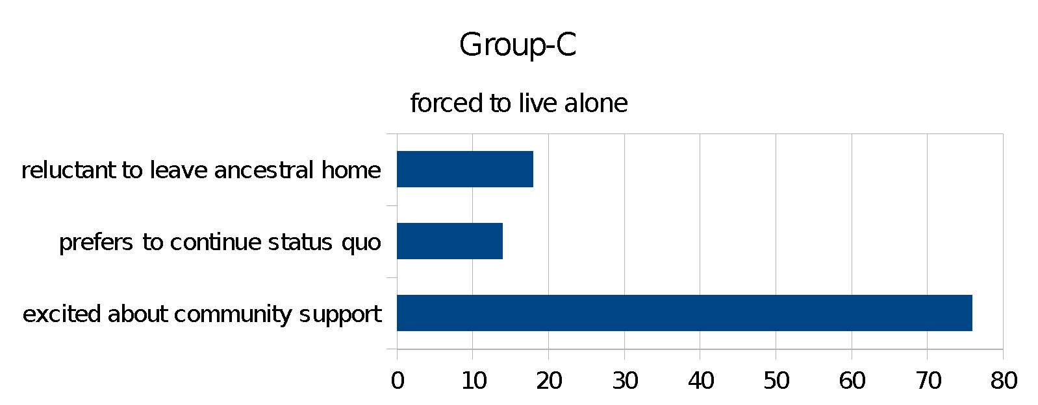

Conclusion
Given the scenario of extended life spans, the day-to-day inter-generational conflicts and contradictions, particularly in the context of variable lifestyles, it is not only necessary but crucial to promote the best options and make the right choices at the right hour.
Here is a movement towards improving living systems within families, managing relationship issues within generations and raising general awareness about possibilities and the positive sides of the entire scenario. This is not an individual research or a part of any vested interest towards promoting any business venture.
Some questions remain to be answered.. What is the right age to move into a retirement home or assisted living? What can be a ballpark figure on the costs of living in such communities, as compared to outsourced and flexible support in one's own home? Do the rules and regulations of senior homes come in the way of one's freedom and social space? They say old habits die hard”!

REFERENCES
National Portal of India; https://www.india.gov.in/topics/social-development/senior-citizen

Paltasingh, Tattwamasi and Tyagi, Renu. 2015: “Caring for the Elderly: Social Gerontology in the Indian Context”. New Delhi, SAGE Publications
Pearce, Benjamin W. 2011: “Senior Living Communities: Operations Management and Marketing for Assisted Living, Congregate and Continuing Care Retirement Communities”, Baltimore MD, JHU Press, 360pp
National Legal Services Authority (NALSA): “Legal Services to Senior Citizens Scheme, 2016”.
Chakraborty, Nilanjana : Things to consider while choosing a retirement home ET, Sept 18, 2017 https://economictimes.indiatimes.com/wealth/plan/things-to-consider-while-choosing-a-retirement-home/articleshow/60708049.cms
Ashiana Housing Care Home: “8 things you should know about care homes in India” Dec 15, 2015 https://www.ashianahousing.com/real-estate-blog/8-things-you-should-know-about-care-homes-in-india
Senior living homes / Assisted Living / Retirement communities / Old age homes in India (List) http://www.seniorindian.com/old_age_homes_list.htm

