Type of Contribution: PAPER

Data Literacy as a Human Right: Roles and Responsibilities of Libraries as Datamediaries

Sheila Corrall, University of Pittsburgh, USA, scorrall@pitt.edu

Keywords: data culture; data literacy; human rights; human-data interaction; social justice.

Introduction
Data literacy is the wicked problem of the 21st century. Big data has transformed science, business, and politics, and is a constant force in our personal, social, and civic lives. In the public sector, a philosophy of open data to improve transparency is being espoused by governments around the world. Big data 2.0 is converging e-science with business intelligence, crowdsourcing, data analytics, social media and Web 2.0 technologies to create very large-scale interdisciplinary healthcare research programs, raising policy, legal, and ethical issues that resonate with the professional values of librarians. Every day we all interact with data as users, subjects, and producers, knowingly and unknowingly, as data permeates our activities at work, visits to websites, and exchanges with friends. Industry leaders, media commentators, and policy advisors argue that the entire workforce and every citizen must become data literate for success in our data-rich society. Yet there is no consensus on how to get there, who should lead the way, or even what data literacy means in our connected open data society

Theoretical framework
The study used three frameworks to guide the investigation and focus the analysis of evidence.
We used Radical Change Theory (Dresang, 1997; Dresang and McClelland, 1999) to frame a description and explanation of the complex, pluralist context for data literacy development, to show how the data deluge has resulted in a fourth research paradigm, represented by data-intensive science (Bell, Hey, and Szalay, 2009; Hey, Gannon and Pinkelman, 2012; Critchlow and van Dam, 2013), alongside a parallel fourth industrial revolution arising from the (big) data explosion that has transformed decision making in business, government, healthcare, and all sectors of society, so that data is now recognized as a corporate asset and strategic resource for corporations, institutions, communities, and individuals (Hiltz, 2017; Mandinach and Jackson, 2012; Mayer-Schönberger and Cukier, 2013; Rainie, Schultz, Briggs, Riggs, and Palmanteer-Holder, 2017; Schwab, 2016; Weigend, 2017).
Radical-change theory was developed in the 1990s to explain changes observed in contemporary books for young people (Dresang, 1997; Dresand and McClelland, 1999), but later applied in other contexts, notably changes in information behavior and resources (Dresang, 2005) and the state of intellectual freedom in librarianship (Dresang, 2006), as an explanatory framework and an investigative orientation. The theory is based on “the digital age principles of interactivity, connectivity, and access”, which it “applies…to explain both some information resources and some information behaviors” (Dresang, 2005, pp. 178, 180). Dresang (2006, p. 183) next suggested that “many, if not most, aspects of contemporary society can be explained by [these] three digital age principles”.
Using this framework, Dresang and McClelland (1999, p. 161) identified three major types of change in literature for youth: changing forms and formats, changing perspectives, and changing boundaries (in subject, character, and theme). Dresang and Koh’s (2009) expansion of the theory established 13 digital age information behavior characteristics associated with three types of behavior corresponding to the three-part typology for books, and also proposed a model for a research agenda extending the scope of investigation to young people’s shared activities online; their civic engagement and its democratic potential; and the dialectical relationships and interactions between information resources, information user behavior, and information-seeking skills/competence.
Although the theory was developed to investigate the behavior of young people, the digital age principles, resource and behavior typologies, holistic research agenda, and focus on interaction provides a promising framework for investigating human-data interaction and data literacy. Figure 1 displays the modified version of the Dresang and Koh (2009, p. 44) model adopted in the present study.
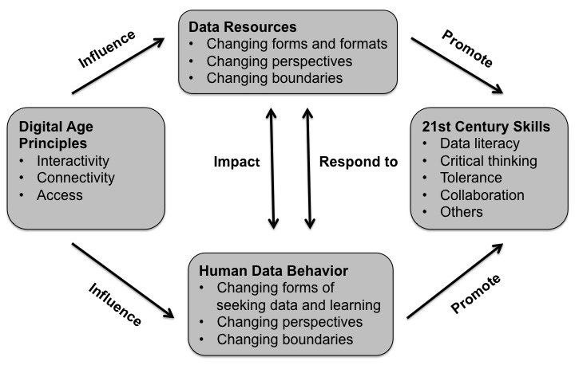
Figure 1. Data Literacy Research Agenda Applying Radical Change Theory

We used the Theory of Stakeholder Identification and Saliency (Mitchell, Agle and Wood, 1997) to identify and classify groups and individuals with interests and/or involvement in data literacy, and evaluate their potential to influence its development. Stakeholder is defined here as “any group or individual who can affect or is affected by the achievement of the organization's objectives" (Freeman, 1984, p. 46). Mitchell et al.’s (1997, p. 854) theory classifies stakeholders on the basis of their possession (or perceived possession) of one, two, or all three of the following attributes: their power to influence the firm [organization or other entity], the legitimacy of their relationship with the entity, and urgency of their claim on it. These attributes have three important features that determine how stakeholders gain or lose salience to the organization, and give the theory its dynamism (Mitchell et al., 1997, p. 868):
- Stakeholder attributes are variable, not steady state.
- Stakeholder attributes are socially constructed, not objective, reality.
- Consciousness and willful exercise may or may not be present.
Mitchell et al.’s (1997) theory was selected both for its longevity and dynamism, and particularly for its nuanced depiction of stakeholders categorized by their attributes, and specific focus on “who really counts for the firm” (Bonnafous-Boucher and Rendtor, 2016, p. 3), which suggested it would be a better fit for the complex-pluralist context of the 21st century big-data landscape than simpler models such as the two-dimensional power-interest grid (Ackermann and Eden, 2011, pp. 182-186; Freeman, 1984, pp. 60-62). Figure 2 displays Mitchell et al.’s (1997, p. 874) hierarchical typology showing how stakeholders are classed as having low (areas 1, 2, and 3), moderate (areas 4, 5, and 6), or high salience (area 7) according to the attributes possessed.
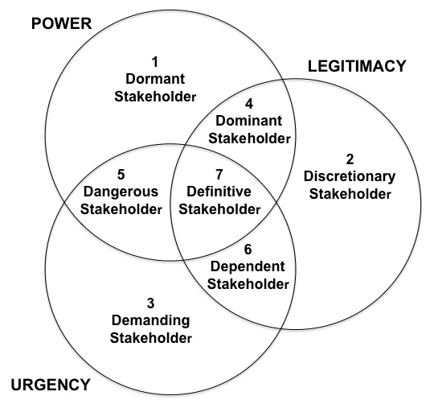

Figure 2. Stakeholder Typology Applying Identification and Salience Theory
Finally, we drew on intellectual capital theory to review and appraise the roles (actual and potential) of libraries in advancing the data literacy movement, specifically Itami’s (1987) concept of an overextension strategy, which encourages organizations to enter new business areas and/or perform different professional tasks before they are completely ready, working in learning-by-doing mode; leveraging and capitalizing on existing know-how, but stretching their current invisible (intellectual) assets by extending their use to novel activities that create new assets. (Itami’s concept anticipates Hamel and Prahalad’s 1993 notion of “Strategy as stretch and leverage”.) Intellectual capital was defined by Stewart (1997, pp. ix-x) as “the sum of everything everybody in a company knows that gives it a competitive edge …intellectual material – knowledge, information, intellectual property, experience – that can be used to create wealth”.
Also referred to as intellectual or intangible assets, it has traditionally been conceptualized as a three-part construct, comprising human capital, structural (or organizational) capital, and relational (or market/customer) capital (Bismuth and Kirkpatrick, 2006; Snyder and Pierce, 2002). However, others have argued for more elaborate models that better reflect the characteristic assets of 21st century organizations: for example, subdividing structural capital to recognize the value of technological assets; and developing the relational capital component to acknowledge a distinction between business and social/community relations. The Intellectus Model of intellectual capital presented by Bueno, Salmador, and Rodríguez (2004, p. 568) exemplifies this approach and was chosen for the present study as the authors characterize the social component in ways that speak directly to the library community, referencing “solidarity and social cohesion”, “scientific and technological development”, and “cultural and artistic heritage” (Bueno et al., 2004, p. 569). Figure 3 displays the model, showing how the social capital component is further subdivided into integration and innovation components.
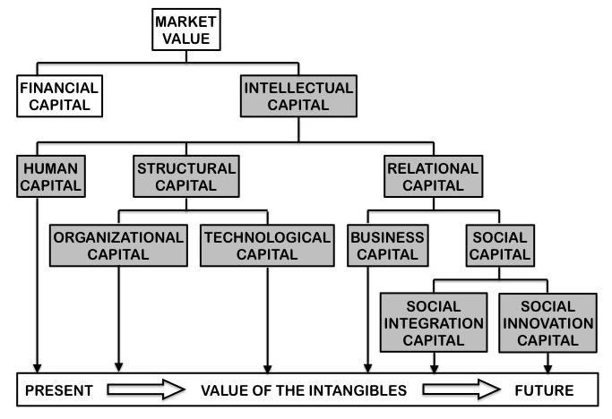
Figure 3. Intellectus Expanded Model of Intellectual Capital
Research questions
- What does it mean to be data literate in the contemporary digital world?
- Who are the critical stakeholders for the data literacy movement?
- How should libraries respond to the data literacy challenge?

Methodology
The research is a conceptual study based on a review of scholarly, professional, and business literature from multiple domains and secondary data from published case studies, which were analyzed and interpreted using established theoretical frameworks.

Research Results
Conceptions of data literacy have evolved from traditional interpretations based on numeracy, quantitative and statistical literacy to social sciences models incorporating critical thinking and information literacy, and STEM perspectives requiring understanding of data lifecycles, laboratory routines, metadata schemas, and collaborative tools; in business and education it is associated with analytics and decision making. Preparing people for personal and social data interactions is an emergent area of concern. Librarians, teachers, academics, consultants, and journalists are all getting involved, usually only in their own areas, but there are some examples of cross-sector collaborations (academic-school and academic-public libraries).

Discussion
Most of the evidence comes from higher education and academic libraries, but there are also initiatives with young people and adults in school and public libraries, and growing recognition of the need for more holistic joined-up strategies to equip students with analytical and other skills required for increasingly data-rich workplaces (and personal lives). Resources and support for the general public are starting to emerge, but there is relatively poor coverage of the social and political dimensions of data literacy. Sector-specific approaches predominate, although there are examples of more holistic strategies for information literacy instruction that could be adopted for data literacy.

Conclusion
We need a new integrative approach to data literacy that moves across and beyond traditional disciplinary and professional silos, mediating diverse contexts and settings, and facilitating lifewide and lifelong learning for individuals, teams, organizations, and communities, including multiple roles and modes of engagement with varying forms of data and other resources, so we can empower people of all ages to deal with data competently and confidently in their personal and social interactions in addition to their educational and professional activities throughout the course of their lives, and provide the necessary support for formal and informal learning at different life stages.

REFERENCES
Ackermann, Fran, and Colin Eden. 2011. Strategic management of stakeholders: Theory and practice. Long Range Planning 44 (3): 179-96.
Bell, Gordon, Tony Hey, and Alex Szalay. 2009. Beyond the data deluge. Science 323 (5919): 1297-8.
Bismuth, Annabel, and Grant Kirkpatrick. 2006. Intellectual Assets and Value Creation: Implications for Corporate Reporting. Paris, France: Organisation for Economic Co-operation and Development. https://www.oecd.org/corporate/ca/corporategovernanceprinciples/37811196.pdf
Bonnafous-Boucher, Maria, and Jacob Dahl Rendtorff. 2016. Stakeholder Theory: A Model for Strategic Management. Cham, Switzerland: Springer.
Bueno, Eduardo, Marí Paz Salmador, and Óscar Rodríguez. 2004. The role of social capital in today's economy: Empirical evidence and proposal of a new model of intellectual capital. Journal of Intellectual Capital 5 (4): 556-74.
Critchlow, Terence, and Kerstin Kleese van Dam, Eds. 2013. Data-Intensive Science. Boca Raton, FL: CRC Press.
Dresang, Eliza T. 1997. Influence of the digital environment on literature for youth: Radical change in the handheld book. Library Trends 45 (4): 639-63.
Dresang, Eliza T. 2005. Access: The information-seeking behavior of youth in the digital environment. Library Trends 54 (2): 178-96.
Dresang, Eliza T. 2006. Intellectual freedom and libraries: Complexity and change in the twenty‐first‐century digital environment. Library Quarterly 76 (2): 169-92.
Dresang, Eliza T., and Kyungwon Koh. 2009. Radical change theory, youth information behavior, and school libraries. Library Trends 58 (1): 26-50.
Dresang, Eliza T., and Kathryn McClelland. 1999. Radical change: Digital age literature and learning. Theory into Practice 38 (3): 160-7.
Freeman, R. E. 1984. Strategic Management: A Stakeholder Approach. Boston: Pitman.
Hamel, Gary, and C. K. Prahalad. 1993. Strategy as stretch and leverage. Harvard Business Review 71 (2): 75-84.
Hey, Tony, Dennis Gannon, and Jim Pinkelman. 2012. The future of data-intensive science. Computer 45 (5): 81-2.
Hiltz, Allison. 2017. Big data: Strategic assets. State Legislatures 43 (5): 8-11.
Itami, Hiroyuki. 1987. Mobilizing Invisible Assets. Cambridge, Mass: Harvard University Press.
Mandinach, Ellen B., and Sharnell S. Jackson. 2012. Transforming Teaching and Learning through Data-Driven Decision Making. Thousand Oaks, CA: Corwin Press.
Mayer-Schönberger, Viktor, and Kenneth Cukier. 2013. Big Data: A Revolution that will Transform How We Live, Work, and Think. Boston: Houghton Mifflin Harcourt.
Mitchell, Ronald K., Bradley R. Agle, and Donna J. Wood. 1997. Toward a theory of stakeholder identification and salience: Defining the principle of who and what really counts. Academy of Management Review 22 (4): 853-86.
Rainie, Stephanie Carroll, Jennifer Lee Schultz, Eileen Briggs, Patricia Riggs, and Nancy Lynn Palmanteer-Holder. 2017. Data as a strategic resource: Self-determination, governance, and the data challenge for indigenous nations in the United States. International Indigenous Policy Journal 8 (2): art. 1.
Schwab, Klaus. 2016. The Fourth Industrial Revolution. Geneva, Switzerland: World Economic Forum.
Snyder, Herbert W., and Jennifer Burek Pierce. 2002. Intellectual capital. Annual Review of Information Science and Technology 36: 467-500.
Weigend, Andreas S. 2017. Data for the People: How to Make our Post-Privacy Economy Work for You. New York, NY: Basic Books.

