PAPER

The COBISS System as a Service Suited to the Needs of Librarians, Researchers and Readers

Davor Bračko, IZUM – Institute of Information Science, Maribor, Slovenia, davor.bracko@izum.si

Keywords: user response, service quality, efficiency, user satisfaction, user experience

ABSTRACT
Theoretical framework: We would like to present the applicability of the COBISS system (Co-operative Online Bibliographic System and Services) to the wider expert community. As a foundation of culture, science and education, the COBISS system meets the needs of librarians, researchers and readers, enables the fulfilling of goals needed for the transition to and functioning in the modern and efficient knowledge society. The COBISS system operates and is developed in accordance with the guidelines dictated by national and European directives, technological and social progress, and particularly by the users of the services themselves. In this paper we would like to show the effects and the results of implementing user feedback, which enables the users to co-create the COBISS System.

Methodology & Research: A number of various resources of feedback and different types of sampling were used. Quantitative and qualitative analyses were performed concerning the quality of bibliographic records, surveys of training course participants, comments from users of the mobile app and web services, user requests and commendations as well as their satisfaction with the provision of reference help and other forms of help. Additionally, the analysis regarding the compliance of the COBISS system services with the latest guidelines of the EU directives was also performed.

Research Results: The analyses have shown that monitoring the feedback and the resulting activities targeted towards the improvement of the services have led to greater satisfaction with the services of the COBISS system. A constant increase in the use of the services, a larger reach and usability of the COBISS system whilst enabling a more efficient and comprehensive e-access to information in libraries to the widest range of users, including the underprivileged, have also been recorded.

Research limitations: The results provided by the paper are based on the overview of the results of the analyses performed in the context of user feedback. The research is repeatable and it does not directly include the local COBISS applications.

Research originality and usability: A research on such a scale and with as many factors of the COBISS system has not yet been performed. This is the first publication of results of qualitative and quantitative analyses, which include the feedback from a wide range of COBISS system users and their effect on the quality of services.

The purpose of the research is to answer the question: How does respecting user feedback improve the service quality and user experience of the COBISS system?

Introduction
This paper includes the areas and services of the COBISS system that have a direct and indirect impact on the results of librarians' and researchers' work representing the expert community, and on the usability of the information from end users of library services representing the public community. For different segments of users and different services their feedback was used in different forms, using quantitative and qualitative methods, the results of which are implemented in order to improve the quality of services. This means that the quality of individual COBISS system services is also a result of the user response regarding the services themselves.

About the COBISS system
Library information systems represent a very important infrastructure for the modern knowledge-based information society. They are essential for the modern education system and research as well as for cultural, technological and economic development. Libraries have to keep pace with knowledge and culture, and they must provide conditions required for dialogue and cooperation, which represent the most important basis for development. Libraries can do this more effectively if they are linked in a uniform library information system. The COBISS system is a part of the national library information system, on which the school system and research as well as cultural, technological and economic development in Slovenia and in some other countries of the region are based.

COBISS represents an organisational model of joining libraries into a library information system with shared cataloguing, the COBIB shared bibliographic/catalogue database and local databases of participating libraries, the COLIB database on libraries, the CONOR authority database, and with a number of other functions. COBISS has been providing e-services supported with modern information and communication technology to libraries and library users since the 1980s. This has resulted in an increased provision of e-services to library users in Slovenia and abroad, and in the increase of their reach, considering and responding to the challenges of the modern society, such as diversity, integration, fairness and adaptability for various user groups and profiles. (COBISS Platform, 2018)

In 2017, Slovenian libraries created 155,879 bibliographic records (on books and for the needs of bibliographies) in the COBIB.SI shared bibliographic/catalogue database that now holds 5 million records, which belong to the 21-million strong holdings of the Slovenian libraries. (Kazalci rasti, 2018) These records on books, articles, journals, graphic material, CDs, films and other material types are available to public and searchable with the COBISS software. The COBISS end users are primarily library members (1,2 million memberships in Slovenia), researchers, librarians and others. (Kazalci rasti, 2018) Thus, the range of users, for whom the software is intended, is very wide. The method of use also varies considerably. COBISS must fulfil the needs of different user profiles, from a primary school student, who is only renewing a loan for books they need for their school project, to a researcher, who is using logical operators in advanced search to find scientific articles. The software is intended for everyone, who is looking for relevant information or material available in Slovenian libraries, and this also includes electronic material.

Despite dealing with very different user profiles, all users expect the software to fulfil their needs or help them achieve a goal. This is where the role of designers and developers comes into play. Their task is to create a product that will guarantee the best user experience to the widest range of users and in the most uniform and efficient way. In order to achieve this, we are designing the COBISS software in accordance with:
1. The guidelines of the financier and the EU agenda
2. Technological and social development
3. User opinions and requests

Field definition and problem description
Monitoring user response is vital for the development of high-quality services, whose purpose is to serve users according to their needs and wishes. User satisfaction should be the guideline or the most desired outcome of the relationship between an organisation and a user. This is why monitoring user feedback and their satisfaction with services and software is a crucial criterion for quality assessment.

The purpose of the research is to examine, how the COBISS system reacts to changes in the environment that it covers and manages, how it deals with emerging methods and technologies and how it looks for new opportunities within them. The research presents several services of the COBISS system, including the methodology for monitoring user response and quality assessment:

- Responsibility for the quality of bibliographic records
- Impact of opinions and user requests on application usability
- Satisfaction analysis of training participants and Reference service users
- Simpler and more effective way of accessing information in libraries
- Impact of compliance of the COBISS system with national and European directives on user satisfaction

The purpose of the research is to examine the usability of COBISS through libraries for end users, its compliance with the high standards of the EU digital agenda, etc., and the responsibility for its users on all levels and for all target groups, including those less privileged.

Shared cataloguing and responsibility for the quality of bibliographic records
Shared cataloguing enables a rational division of labour and saves time and effort in the demanding procedure that is processing library material and maintaining catalogues. Once a bibliographic record is processed, it is available to all other participants in the system and the COBISS.net network through the COBIB shared bibliographic/catalogue database.

In shared and local databases in the COBISS.net system, as well as in the Slovenian COBISS.SI system, several quantitative milestones were passed: in the local COBISS.net databases, the 25-millionth record was created; in the local COBISS.SI databases the 14-millionth record was created; and in the shared COBISS.net databases, the 11-millionth record was created. (Kazalci rasti, 2018)

The databases store bibliographic records for different types of material (monographs, serials, integrating resources, articles and other component parts), for the purposes of managing personal bibliographies of authors and researchers, and also for performed works.

The quality, uniformity and consistency of the local databases and that of the COBIB shared database are provided in different ways: by authority control for authors’ personal names, by duplicates control, by COMARC software controls, by record editing, by global code lists for all standardised data (e.g. countries, languages, UDC), by local code lists to provide uniformity of data within a library (e.g. locations, internal designations), by automatic counters (e.g. accession numbers, numbering in call numbers), by unique identification control of serials, etc., and above all by providing a systematic training for record creators and integrating the COMARC formats documentation into software. (COBISS Platform, 2018)

The shared cataloguing system is conceived in such a way that each bibliographic resource is catalogued only once; once catalogued, the record for this resource becomes available to all COBISS.net network members. Consequently, the quality of bibliographic records in the COBISS system is of utmost importance. Records represent the basis of the bibliographic/catalogue databases and, thus, of the COBISS system. The quality of bibliographic records has an impact on the services available to people searching for information and to library visitors. In addition to this, records represent the basis for personal bibliographies and bibliographies of research groups, and for the calculation of the lending remuneration. Exchange of records with foreign providers and databases such as WorldCat and UNESCO is also worth mentioning. Assuring the quality of bibliographic records is thus of vital importance for the quality level of the system as a whole.

IZUM's Bibliographic Control Department monitors the quality of records and consequently the quality of the COBIB shared bibliographic/catalogue database. Thus, 77 checks were carried out and 723 records were checked in 2016 by the Bibliographic Control Department (Dornik et al., 2017, p. 196).

Creators and editors are responsible for the quality of bibliographic and authority records in the COBIB.SI shared database. The quality of these records is monitored by authorised reviewers. Twice a year, a check of at least 50 randomly selected bibliographic and authority records is performed on the original documents. The procedure checks if the data complies with the COMARC format rules and cataloguing rules. Copying data from publications must be carried out with great caution, as incomplete or incorrect data misleads not just users, but cataloguers, who download these records, as well. The checked records are evaluated with respect to the number of errors they contain. A record can have one of the following grades: adequate record, record with minor errors or record with major errors.

In 2017, we performed two random selections and checks of bibliographic records and the corresponding authority records. Out of 100 checked records, 24 contained major errors, 55 contained minor errors and 21 were of adequate quality. (Kurnjek B., Kavčič I., 2018) Over the last 10 years, 997 records were checked this way. The creators and editors of records are notified about the findings and asked to update the records or correct the mistakes they contain. In case of major errors, the responsible person from the library of the cataloguer is notified as well.

Compared with 2008, the number of records of adequate quality in 2017 rose from 8 to 21, which is an improvement of 162%.

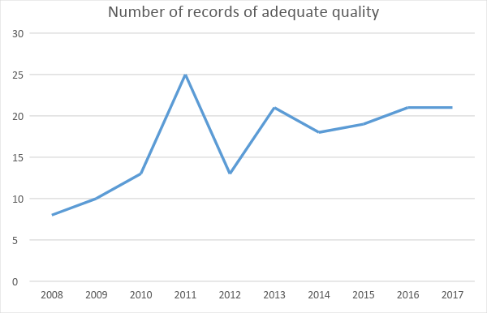
Chart 1: Rise of the number of records of adequate quality from random checks
If we transpose this sample to the total growth of bibliographic records in the COBIB.SI shared database, which in 2018 amounted to 1,065,185 records (173,049 of which were created), and in 2017 to 949,954 records (155,879 of which were created), we see quite substantial numbers of improved records. These numbers prove that regular quality checks of bibliographic and authority records lead to an improved quality of the COBIB.SI shared database.

Impact of user opinions and requests on the usability of the COBISS+
Libraries are treasure troves of knowledge holding millions of items. Searching for library material has been computer-aided for several decades, and development in this field in recent years has been especially rapid. New technologies are emerging, new options are presenting themselves, and – most of all – the habits and demands of users, searchers of information, are changing. The experience of many internet users today is shaped by internet giants and social media. That is why the usability of software, which enables access to information in library catalogues and other databases, is a vital factor in guaranteeing a user experience that the users of modern internet solutions are expecting.

At the end of 2017, COBISS+ replaced COBISS/OPAC, the online application that served its users more than two decades. Today, COBISS+ enables libraries and end users to access information in over 1221 libraries in Slovenia and the neighbouring region. (Cobiss.net, 2018) The COBISS+ software was developed from scratch, and along with all of the functionalities of its predecessor, it offers users a range of new features.

COBISS+ is the part of the COBISS system that is intended to the widest range of users. These primarily include library members, researchers and, naturally, librarians. In 2016, users sent 12,088 requests to IZUM user service; (Kazalci rasti, 2018) 368 of those requests were related to COBISS/OPAC, from reported bugs in operation to requests for additional functionalities.

No. | Request No. | Status | Group | Title – name of request | Short request description | Request date | Request submit-ted by | References | Priority level | Request entered by
2 | 01-002 | POS | D | WWW interface: search | Number of records displayed in search results, maximum value should be increased (100, 200, 500?). | 2002-01-10 | OPACUSER | SRV315/(2002)FW: OPC29/(2002)Predlog; SRV3321/(2002)FW: OPC460/(2002) | 3 | MD
90 | 01-090 | RAZ | D | WWW interface: session expiry | Some users are experiencing problems when logging into COBISS/OPAC. They immediately receive the following message: "Your session has expired." You could also add information to the site that displays this message on how to solve the problem – a link to a document describing the required browser settings. | 2004-05-27 | OPACUSER | OPC5019/(2004) | 2 | MD
315 | 01-315 | POS | P | OPAC – reservation of material | Suggestion to change the procedure for reserving several copies of material. Individual copies could be added to a temporary list and in the end you would reserve all of them simultaneously. | 2011-09-13 | OPACUSER | OPC1018/(2011) | 2 | md
341 | 01-341 | POS |  | List of search results | Improvement of weighting and ranking. If, for example, there is '4' in the title, subtitle or keyword, the search result should appear higher on the list (e.g. "Matematika 4"); if the '4' appears in the ISBN, publication year, etc., it should appear lower on the list. | 2011-11-28 | Sloveni-an Public Libraries Associa-tion |  | 2 | md
Table 1: Sample of the list of requests for updates, upgrades and fixes in COBISS/OPAC

Alongside these user requests that were analysed and taken into account when designing the new version of the COBISS/OPAC, we have given COBISS+ users the chance to send their feedback from the interface itself. We have added a form titled Your opinion on COBISS+ to COBISS+, through which we collect user opinions that are then analysed by designers. Over the last six months (from 3 October 2017 to 3 April 2018), 162 comments were submitted through this form. Eight of those structured comments and several general comments were implemented.

USER COMMENT:
Greetings,
Through my daily interaction with the users (at the Ljubljana City Library), I have realised that many of them (at least one user a day) have problems navigating to loan renewal on a new page. After they log in, they are not aware of the fact that they should open the "My library" tab. I personally also think that the method for renewing the loan should be simpler. It would be helpful if the first window after the login would display a list of libraries above the material search field.
REPLY:
Dear Sir or Madam,
We thank you for your opinion regarding loan renewal in COBISS+. Other users have also noticed the problem you mentioned, which is why we intend to implement the proposed solution in the next installation of the new version expected to be released by the end of the year.

These requests are one of the most important catalysts of development of the new COBISS+ web application. The requests are analysed for their sensibility and feasibility and then placed on a waiting list before they are implemented. This way all users of COBISS+ have the chance to affect the development of the software and co-create it, so that it is suited to the needs and requests of the actual users.

Another key criterion for developing COBISS+ apart from user requests was the evaluation of COBISS/OPAC user efficiency. The evaluation was performed by the Institute of Informatics at the Faculty of Electrical Engineering and Computer Science, a member of the University of Maribor, according to the guidelines of the ISO/IEC 25062 COMMON INDUSTRY FORMAT FOR USABILITY TEST REPORT standard. The purpose of the evaluation was to test the usability level of the COBISS/OPAC web application.

Usability was evaluated using the following parameters:
• satisfaction with use
• efficiency
• performance, etc.

Satisfaction with use consists of the following criteria:
• simplicity of use
• organisation of information
• data and information labelling
• appearance
• website contents
• response to user mistakes (e.g. wrong entry)

We included representatives of the whole population of potential users of the COBISS/OPAC web application, with the exception of the target group "library employees", who were exempt from testing. The purpose of the test was to establish the usability level of the COBISS/OPAC web application for individual user groups, and to gather their subjective opinion. Also part of the test was an expert evaluation, the purpose of which was to obtain information on the achieved usability level of the COBISS/OPAC web application on the basis of the subjective opinion of three experts from the field of online information system development and design as well as objective evaluation of the measurable values. The aim of the expert evaluation was to get an opinion on the compliance of the design, which affects the usability of the COBISS/OPAC web application, with the usability standards and good practices.

POSITIVE | NEGATIVE
- Simple to use  - Consistency and systematic approach  - Efficient operation for most users  - High performance | - Appearance  - Logging into "My library"  - Mandatory selection of database  - Technical terminology
Table 2: Summary of results of the COBISS/OPAC user efficiency evaluation

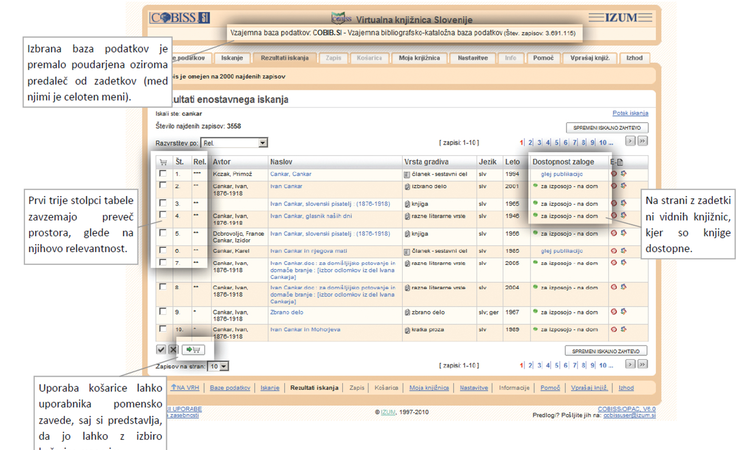
The selected database is not emphasized enough and is too far from search results (there is a menu between these two elements).
The first three columns take up too much space given their importance.
The "Add to cart" button could mislead the user into thinking they can reserve material by clicking it.
The search results page does not display libraries, where the books are available.
Figure 1: Suggestions from the evaluation regarding the display of search results in COBISS/OPAC that were taken into account when designing COBISS+

User requests, usability evaluation results and use analysis are the basis for the quantitative and qualitative analyses with which the usability is researched and the COBISS+ software is upgraded. These are the catalysts of development that have led to the updated COBISS+ application, with which we want to improve the satisfaction of COBISS services users even further.

mCOBISS mobile app as a simpler and more effective method of accessing information in libraries

mCOBISS is the mobile version of COBISS+, which was developed in accordance with modern trends and based on modern technologies. It provides a faster and simpler access to a wide range of COBISS services, improves their availability, efficiency, impact and user experience, and by doing so considerably simplifies the access to the right information at the right time.

The mCOBISS app is an innovative solution that does not only fulfil the existing needs but also encourages and fulfils new needs and eliminates the present-day problems of the digital society. It also increases the range of e-services available to library users in Slovenia and abroad, and expands their reach to the field of mobile devices.

Parallel with the phenomenon of shifting the internet use from desktop computers to mobile devices witnessed in the past years is the rise in use of the mCOBISS app. Yet despite this organic growth, it is crucial to pay attention to the trends set by the mobile industry giants in order to keep the users of the mobile app satisfied. Changes in the design of mobile apps occur faster than in other (computer or online) applications. Thus, paying attention to user comments and trends is of utmost importance when designing the mCOBISS app in order to reach and maintain the highest standard of quality. This is the only way for mCOBISS to provide a simpler, more effective and wholesome e-access to information in Slovenian libraries to the widest range of library service users.

In order to achieve this level, it is crucial to pay attention, analyse and especially take into account user responses. Over a thousand of them rated the mCOBISS app, giving it a grade of 4+ in the iTunes store and a grade of 4,4 in the Google Play store. (mCOBISS in Google Play and iTunes store, 2018)

Here is an example of a user response in the Google Play store:
"After the latest update, mCOBISS is not as responsive and sometimes it takes ages to process a request!"

On the basis of this comment, we performed a response and speed test of the app's operation on the Android platform, and found a bug. The bug was fixed and the app started performing normally. Thus, we complied with the user's request and improved the performance of the mCOBISS app.

One of the parameters for achieving a better quality of functionality and enhancing the user experience is optimizing the required time for reaching the most frequently used functions of the mobile app. The time needed to reach the required goal on the mobile phone is often very crucial for the usability of the app. The more complicated the app and the more actions it requires the smaller is the probability that the users will prefer the app over the web version of the same service. That is why we measure the duration of user sessions in the mCOBISS app and use it to analyse the efficiency of the app. The average duration of a user session in the iOS version of the mCOBISS app in 2017 was 75 seconds. This includes the time during which the user opens the app on a mobile phone (or tablet), achieves the goal and closes the app.

Date | Average duration of a user session
… | …
4.12.2017 | 78 sec
5.12.2017 | 71 sec
6.12.2017 | 70 sec
7.12.2017 | 75 sec
8.12.2017 | 68 sec
9.12.2017 | 77 sec
10.12.2017 | 70 sec
11.12.2017 | 79 sec
12.12.2017 | 78 sec
13.12.2017 | 77 sec
14.12.2017 | 84 sec
15.12.2017 | 68 sec
16.12.2017 | 68 sec
17.12.2017 | 71 sec
18.12.2017 | 72 sec
19.12.2017 | 77 sec
20.12.2017 | 75 sec
21.12.2017 | 83 sec
22.12.2017 | 75 sec
23.12.2017 | 69 sec
24.12.2017 | 53 sec
… | …
Table 3: Sample of recording the duration of a user session in mCOBISS

For the purpose of optimisation, we selected loan renewal which is the most frequently used action by the users of the COBISS system. In 2017 a total of 26,247,040 material loans were performed (including the renewals). (Kazalci rasti, 2018) This number includes all available types of loan and loan renewals in libraries included in the COBISS.SI system, also via the mCOBISS mobile app.

Based on the current solution and the method of loan renewal we tried to discover how many actions (i.e. touches of the mobile device screen) are needed for the user to arrive to the overview of loaned material, which is the only place where users can renew the loan in mCOBISS app. In the current mCOBISS version four actions are needed. This means that the user has to touch the screen four times to arrive to the overview of loaned material. Multiple measurements were performed that provided the analysis used to optimize the app. The purpose of the optimization was to reduce the number of actions required to achieve the desired goal. A group of designers and developers of the mobile app came up with a solution that will reduce the number of actions required to renew the loan from four to zero. We have achieved this by completely renovating the app interface and in doing so shortened the paths needed to achieve individual goals. This means that in the new version of mCOBISS 3.0 (not yet launched), the overview of loaned material will be accessible immediately after starting the app.
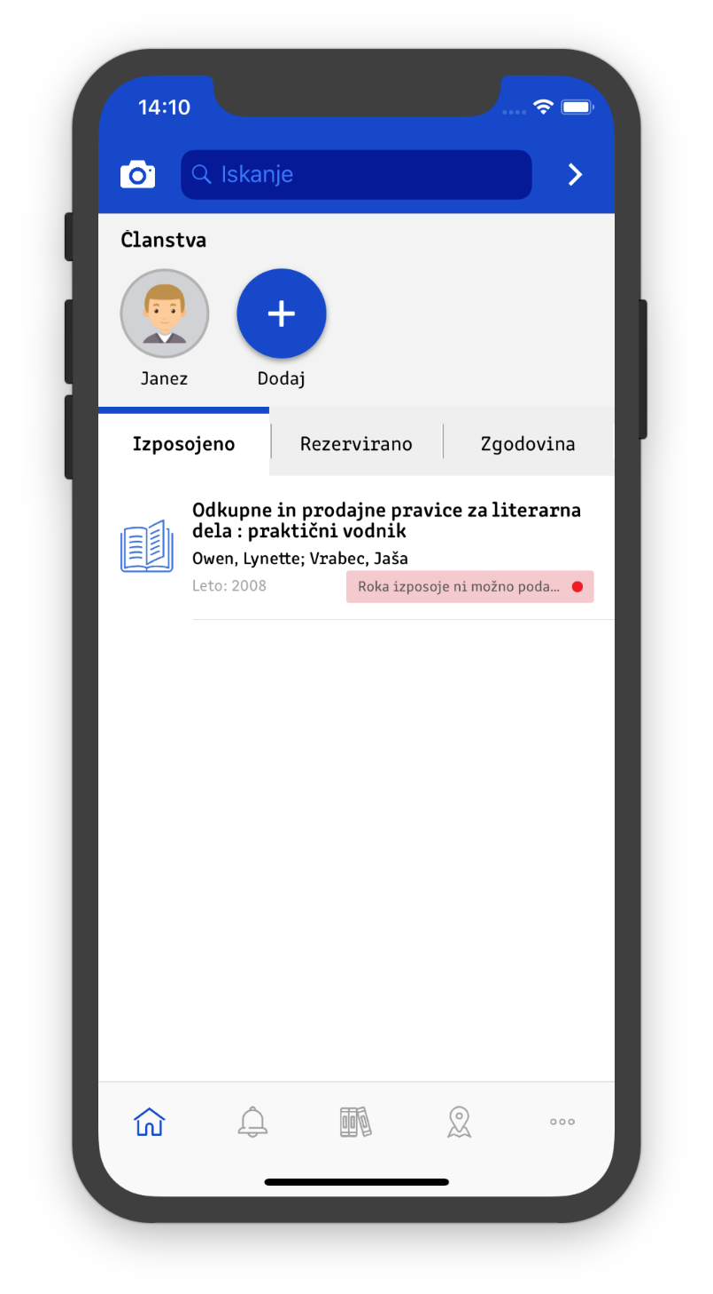
Figure 2: The optimized home screen of the mCOBISS 3.0 mobile app, where the most frequently used functions are available immediately
The changes are quite considerable and the results will be evident only after launching the new version and reviewing user feedback.

The design and development as well as creating a good user experience when using mobile apps is constantly changing. Fast technological development and advanced user requirements constantly offer new opportunities for improvement. That is why one of the most important tasks of our group for developing the mobile app is to consolidate the options and improvements offered by new technologies with the usability of the app and enhancing the user experience. Only an app planned and created in this manner can service its intended users.

Training participant satisfaction analysis
User training is a vital component of the development of every information system. This is why we at IZUM are paying close attention to it. Apart from the typical courses presented in this programme we also organize presentations of new features and special online courses covering a wider area of our activities. In 2017, we conducted 123 classes in 380 days for 1,424 participants. (Kazalci rasti, 2018)

In order to be able to provide high quality training, we monitor the reactions of course participants by conducting surveys. The results of these surveys represent indispensable information for designing courses and choosing the appropriate training methodology. In this way, participants have an impact upon the execution of courses, both from the viewpoint of content and in the way the subject matter is delivered. This research aims to present the qualitative and quantitative analyses of the answers, provided by course participants in the survey on course content and level of difficulty. In this way, we intend to bring the quality of our training programme to a higher level and enhance the participants' satisfaction.

In the surveys, we ask the participants about their opinion on the contents and the difficulty of the course, contents presentation and the quality of the materials and accessories. Based on the assessments and opinions given by the participants we adjust the courses so that they are tailored to participants' needs. This method of collecting participants' opinions is in use since 2005. In 2017, we received 854 filled-out surveys.

For the purpose of this paper, we analysed the opinions of participants of the course titled Downloading Records and Holdings. In 2006, this course lasted 4 days and we received multiple remarks that it is too long:

Sample of collected remarks:
- You should organize a course for actual beginners that couldn't follow the course, while some participants were bored.
- Too much unnecessary theory.
- Everything was executed properly and with quality, the only thing bothering me was repetition of subject matter. I would suggest shortening the course to 2 days and that the theory would be combined with practical examples. I believe that the last, 4th day of the course was the best one. I would like to thank you and wish you success in the future.
- I found the day when we talked about COBISS2 unnecessary. For those of us that are familiar with it, it was boring, and those that are not familiar with it, did not find it useful (in my opinion), because it was presented too quickly.
- It is my opinion that we should focus on the title of the course and work only on records and holdings. Other segments are covered by other courses, anyway. You should also unify the participants (a course only for school libraries, etc.) because the subject we are most interested in is covered only on the last day.

And so, based on the feedback of the course participants, we shortened the course to 3 days in 2007. The course COBISS3/Downloading Records and Holdings in this form was conducted from 2007 to 2015. In this time, we received multiple remarks that the course is too long or that it is not adequately difficult, because it was attended by participants with various levels of prior knowledge.

Sample of collected remarks:
- The course is too easy for the participants who already attended the course COBISS3 Acquisitions and Holdings. Most of the contents and the subject matter was already given in the previous courses.
- I suggest that the subsequent courses are separated for public and school libraries, because there is too much subject matter given for the school libraries.
- I suggest that the courses are conducted separately for the libraries that already use COBISS and the libraries transitioning to the system. E.g. a course for school librarians only, so they could focus on the information that is more useful to them.
- It was distracting that the course was attended by librarians that use COBISS2 and librarians who are not familiar with COBISS at all. For the latter, some information was covered too quickly and for the former the information was boring.
- The course should be organized for different levels of prior knowledge. Separately for the librarians who already use COBISS2 (cataloguing) and separately for the librarians that are seeing this system for the first time.
- In the future, the course (contents) should be adapted separately for school libraries and separately for other libraries.
- I think that some contents could be shortened.
- Too much difference in the level of prior knowledge of the participants – perhaps this could be changed in the future.
- The course could maybe be more concise; in order to make it more compact, intensive and direct.
- I suggest that in the future you separate the librarians who already know how to do this (because they use it in their libraries) from others who have no idea.

As a result of considering the feedback from course participants we shortened the course to 2 days in 2016 and introduced a separate course for participants with less prior knowledge. Since then the remarks from participants regarding the course duration and inappropriate difficulty have drastically decreased and are practically non-existent.

Besides the analysis of participants' commentaries, we also conduct the qualitative analysis of participants' assessments. For the purpose of this paper, we took a closer look at only one of the courses – COBISS3/Loan. We monitored the assessments of material and accessories quality as well as the assessment of contents presentation in the period from 1 January 2012 until 31 December 2017. The marks used for assessment range from one to ten.

The graph below shows the increase of the average participants' mark regarding the material and accessories quality that are used in the course. In the last few years we upgraded the lecture rooms and equipped them with modern accessories, which definitely improved the satisfaction of the participants.
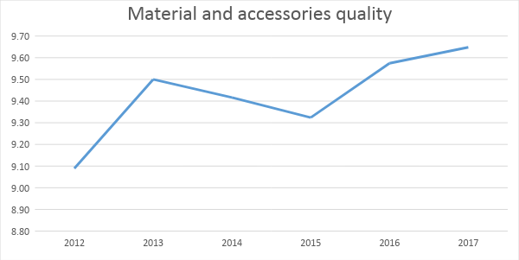
Chart 2: Average marks of participants regarding the material and accessories quality
The participants also evaluate the contents presentation. This area also shows improvement in the marks, which testifies to a better work method of the lecturers.
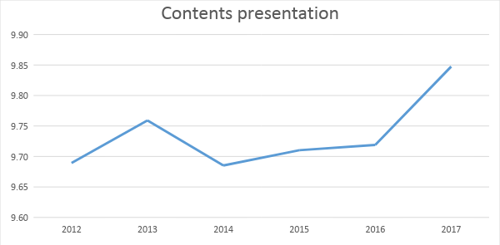
Chart 3: Average marks of the participants regarding the contents presentation

Analysis of user satisfaction with the answers on reference questions
One of the fields, where the COBISS system connects libraries and users of library services, is that of general or reference questions. The Ask a Librarian reference service is designed cooperatively, with the nine included libraries acting as equal participants. This cooperation between libraries in the form of answering reference questions is now in its 14th year. During this period, more than 33,000 questions have been posed by users and answered by librarians. The key component for providing quality answers is monitoring the trend of user satisfaction with the answers and with the reference service as a whole, which we have been doing since the service was established. Once a month, a statistic report is prepared and an analysis of the filled-out surveys is performed to this end.

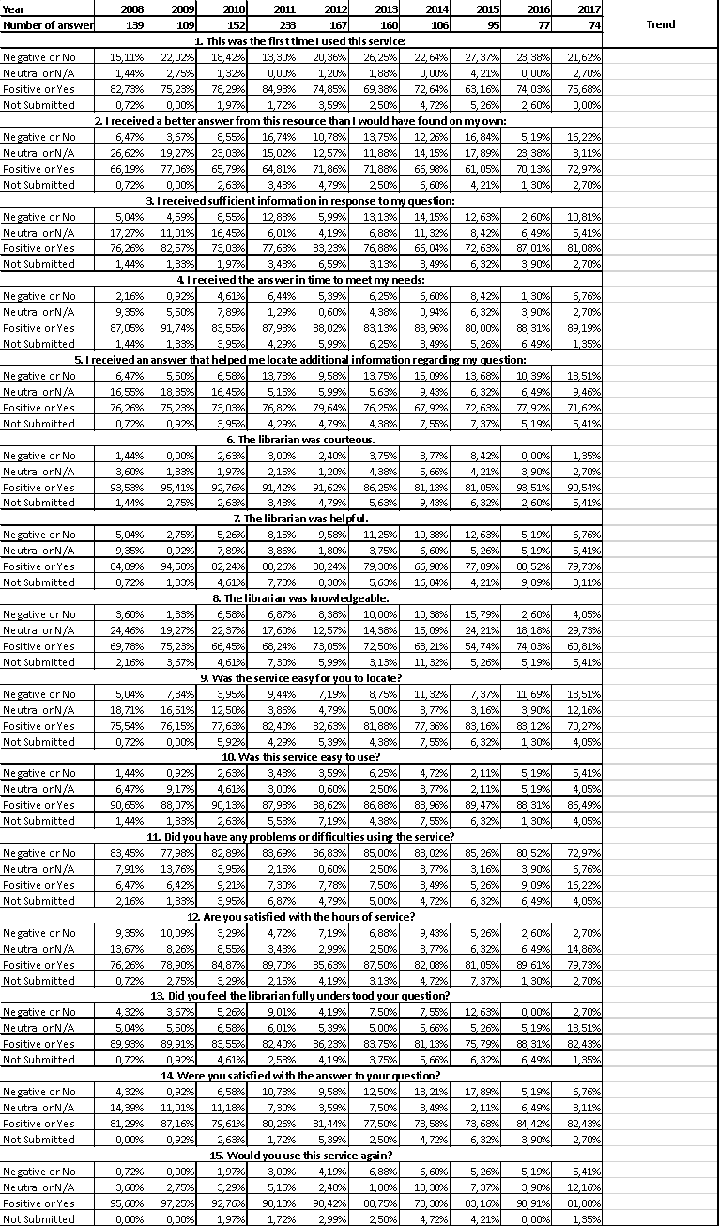
Table 4: Analysis of user feedback regarding the satisfaction with the answers to reference questions from 2008 to 2017
We have been monitoring the feedback from users of the reference service since the beginning of its operation. From 2008 to 2017 we have received 1,312 filled-out surveys. One of the criterions of user satisfaction with the reference service includes the time when the service is available. Namely, the live chat is only available when it is monitored by librarians or IT-personnel on-call, while the questions can be sent via e-mail 24 hours a day. This feedback revealed that there are quite a few requests for chat when the personnel are not on call. Our solution was to extend the on-call time accordingly. The response of the users to this change was positive.

The change of on-call time is only one of the measures adopted based on the analysis of user feedback and it should suffice for the purposes of this presentation. More detailed results of the quality analysis of the reference service answers that indicate an increase of the satisfaction of the reference service users can be found in the master thesis Longitudinalna analiza izvajalcev storitev in zadovoljstva uporabnikov spletnega referenčnega servisa v knjižnicah. (Marolt Zupan, 2016)

This shows that the results of the work of librarians and IT-personnel that work in the online reference service are also influenced by user responses. Furthermore, the work of reference librarians supported by contemporary tools that enable monitoring of user responses is more transparent, which contributes to an improved quality of service.

The impact of compliance of the COBISS system with national and European directives on user satisfaction
Information and communication technologies are an important part of the EU's strategy for strengthening economic growth, promoting European digital potential and responding to the challenges of a modern, global world. The Digital Agenda is one of the seven leading incentives of the Europe 2020 strategy and it should provide a fast, sustainable and inclusive growth to the European Union in this decade.

COBISS is pursuing a global goal – to encourage the development and improve the offer of e-services in different areas of the information society. In doing so, it is directly contributing to the expansion of publicly accessible e-services, and actively shaping the concepts of technological development, organisation and business in the fields of culture, science and education, all of which contributes to the transition to a modern and efficient knowledge society.

Among the more notable topics of the renewed EU strategy for sustainable development, COBISS relates directly to social inclusion, demographic changes and migrations. It improves and facilitates the access to saved contents relevant to a comprehensive development of individuals and communities and also ensures non-discriminatory possibilities for using the most advanced e-services in the field of librarianship. By doing this, COBISS also contributes to recognizing and consequently making the best possible decisions in the present, which will have lasting effects in the digital future.

One of the specific goals is to improve digital literacy. The impact that COBISS has in this area is an obvious added value in the form of a virtual environment. Namely, in the case of the mCOBISS mobile app, users are using new and increasingly accessible devices, which enable them to use the new e-services of the national library system. The services are intended for all, not only for trained users of modern ICT services and devices. Because of their simplicity of use and attractiveness, COBISS can also be used by less-skilled users. Users' understanding and accepting the contents and services is of key importance because this e-service is a result of analysing users' wishes and needs as well as the result of adapting to the capabilities of new devices. mCOBISS includes functions that enable different forms of using remote services for the general public, regardless of the physical location of the user. On top of that, citizens with special needs (especially with motor disorders) have access to completely new possibilities of using library activities, which improves their quality of life and reduces their marginalization (a contribution to e-accessibility).

COBISS is incorporating all seven pillars of the Digital Agenda and is contributing to implementing goals in the field that it covers. Here are some of the concrete results and effects of following the EU Digital Agenda goals:

- Digital single market – the presence of the COBISS information system in the countries of Western Balkans also provides a breakthrough regarding the goals of EU's regional development policy.

- Enhancing interoperability and standards – the services of the COBISS system are completely independent from the technological environment of an individual, which complies with the interoperability principle.

- Strengthening online trust and security – some functions of library services are also related to the sensitive exchange of data and transactions of financial nature. The complete system of digital identity and the transfer of data between the local COBISS applications and serves are securely established with authentication and authorisation mechanisms that protect the security of the flow of sensitive information as well as individual's integrity, which contributes to the enhancement of users' trust.

- Promoting fast and ultra-fast internet access for all – mCOBISS is expanding the availability of e-services in the world of library users to the area of mobile devices. Mobile apps as well as e-services are developed in accordance with the most recent trends and innovative technologies. This ensures user-friendly solutions also for the individuals who have limited resources for integration into the information society. Considering the fact that almost 100 percent of the population has cellular signal coverage, e-services are available practically for all.

- Investing in research and innovation – COBISS integrates innovative ways of using the most important library functions for the users. It is an innovative system of knowledge transfer in education and society and it also brings the libraries and their functions closer to the individual with the use of new e-services and mobile apps. This represents a new added value, which brings the current "standard" library functions directly to the user.

- Promoting digital literacy, skills and inclusion – e-services provided by COBISS are an obvious added value of the virtual environment, because the individuals use new devices, which are becoming more and more available and enable them to use new e-services of library systems. These devices are intended for everyone and not only for skilled users of contemporary ICT services and devices. Because of their simplicity of use and attractiveness they can also be used by less-skilled users.

- ICT-enabled benefits for the society – with the use of e-services, cultural and creative contents are also becoming interesting for other areas, which are less related to libraries, and on the other hand, comparing one's own creativeness with the works already created, can provide even greater creative impulses, which leads to promoting cultural diversity and creative contents.

The COBISS system helps in achieving the goals of the Digital Agenda like diversity, inclusion and adaptability of use for different user groups, including those less privileged.

Discussion and Conclusion
One of the bases of usability of the COBISS system services is the feedback from its users, from librarians and researchers to the community of experts and end users of the library services. Thus, the COBISS system is the result of cooperation between researchers, librarians, general users and others, who co-create it through their requests. And in this way, the COBISS system provides services suited to the needs of its users.

Processing and analysing user responses are the guidelines that lead in the right direction towards better quality services and consequently more satisfied users. Also worth pointing out are the compliance of the COBISS system with the high standards of European directives and the development in accordance with the technological advancements and social progress.

The COBISS system therefore promotes science, creativeness and innovations in the society and education. The direct impact COBISS has is evident in the transfer of knowledge by bringing libraries and their functions to the individual with the use of contemporary e-services and mobile apps, which brings the current "standard" functions in physical libraries directly to the user as a new added value. Solutions offered by the COBISS system are intended for a wide range of users, and with that they collectively follow the global goal – promoting development and a wide range of e-services in different areas of information society. The services of the COBISS system not only fulfil the existing goals, habits and needs of the users, but they also promote the use of new, innovative solutions, all the while ensuring a good user experience. COBISS is therefore expanding the multitude of publicly accessible e-services and co-creates new technological development trends in the fields of culture, science and education promoting the transition into a modern and effective knowledge society.

COBISS as a system should ensure the highest possible level of success, effectiveness and satisfaction felt by the researchers, librarians, general users and others when they achieve their goals by using one of the services. This also includes the majority of groups and individuals with special needs whose access to e-services or the internet is limited for various reasons. This improves the effectiveness and the impact of the COBISS services and provides an easier access to the information and also improves the transfer of knowledge. In order to achieve this, the designers and developers of the COBISS services must follow the standards and the guidelines, technological advancements and social progress as well as the opinions and requirements of the users. This is the correct path to high-quality services that include the user interface and the contents as a homogenous whole. Only a service suited to the need of its users can guarantee a user-friendly experience.

This paper proves that considering user responses and ensuring compliance with modern trends can lead to an improved quality of individual services, which improves user satisfaction with the services of the COBISS system.

REFERENCES

COBISS.net. Retrieved 18 April 2018, from https://www.cobiss.net/si

Digitalna Slovenija 2020 – Strategija razvoja informacijske družbe do leta 2020. (2016). Retrieved 14 January 2018, from http://www.mju.gov.si/fileadmin/mju.gov.si/pageuploads/DID/Informacijska_druzba/DSI_2020.pdf

Dornik, E., Badovinac, B., Kos, J., Farkaš, B. (2017) Sistem zagotavljanja kakovosti COBIB.SI: izbrane aktivnosti za leto 2016. Library, 2017, 61(1–2), 191–205. Retrieved 18 April 2018, from https://knjiznica.zbds-zveza.si/knjiznica/article/view/6167

Kazalci rasti sistema COBISS.SI in obsega dejavnosti IZUM-a. Retrieved 18 April 2018, from http://home.izum.si/cobiss/o_cobissu/statistike_kazalci.asp.

Kurnjek, B., Kavčič I. (2018) Povzetek ugotovitev ob preverjanju 50 naključno izbranih bibliografskih zapisov v COBIB.SI. Retrieved 18 April 2018, from http://home.izum.si/cobiss/obvestila_novosti/dokumenti/Nakljucni_zapisi_povzetek_ugotovitev_20170717.pdf and http://home.izum.si/cobiss/obvestila_novosti/dokumenti/Nakljucni_zapisi_povzetek_ugotovitev_20170823.pdf

Marolt Zupan, Apolonija (2016). Longitudinalna analiza izvajalcev storitev in zadovoljstva uporabnikov spletnega referenčnega servisa v knjižnicah. Univerza v Mariboru, Ekonomsko-poslovna fakulteta. Retrieved 14 January 2018, from https://dk.um.si/Dokument.php?id=91257

mCOBISS in Google Play and iTunes stores. Retrieved 18 April 2018, from https://play.google.com/store/apps/details?id=si.izum.mcobiss&hl=sl and https://itunes.apple.com/si/app/mcobiss/id687682312?mt=8

COBISS Platform. (2018). Maribor: Institute of Information Science. Retrieved 14 January 2018, from https://www.cobiss.net/cobiss-platform.htm

Presoja uporabniške učinkovitosti COBISS/OPAC. (2010) Institute of Informatics FERI.

Rubelj, A., Tacer Slana, J., Šobot, P. (2016) Spletno učenje v skupnosti COBISS.SI. Organizacija znanja, 16(2), 70-76. Retrieved 14 January 2018, from
http://home.izum.si/cobiss/oz/HTML/OZ_2016_2_final/index.html#14/z

Podatki o številu članov knjižnice in uporabi storitev COBISS/Izposoje. (2017) Retrieved 14 January 2018, from http://home.izum.si/cobiss/o_cobissu/dokumenti/STAT_SERVIS_IZPOSOJA_SI_2016.pdf

